**Java Development Kit (JDK)**

**5**

The JDK is a software development kit used to develop Java applications. It includes:

1. **Development Tools:**
   * **Compiler (javac):** Converts Java source code into bytecode.
   * **Debugger (jdb):** Helps in debugging Jaastractva programs.
   * **JavaDoc:** Generates documentation from Java source code.
   * **Other Tools:** Includes tools like javap (class file disassembler), jconsole (monitoring tool), etc.
2. **Java Runtime Environment (JRE):**
   * The JRE is part of the JDK and provides the libraries, Java Virtual Machine (JVM), and other components to run applications written in Java.

**Java Runtime Environment (JRE)**

The JRE is a package of software that provides the necessary environment to run Java applications. It includes:

1. **Java Virtual Machine (JVM):**
   * The JVM is the core component of the JRE that executes Java bytecode.
2. **Class Libraries:**
   * A set of standard class libraries that Java applications can use.
3. **Other Components:**
   * Includes components like Java Plug-in for running applets in browsers and Java Web Start for deploying standalone applications.

**Java Virtual Machine (JVM)**

The JVM is an abstract machine that enables your computer to run Java programs. It has three main components:

1. **Class Loader Subsystem:**
   * **Loading:** Loads class files from the file system, network, or other sources.
   * **Linking:** Verifies, prepares, and resolves classes.
   * **Initialization:** Initializes static variables and executes static blocks.
2. **Runtime Data Areas:**
   * **Method Area:** Stores class structures like metadata, constant runtime pool, and method data.
   * **Heap:** Stores objects and arrays.
   * **Stack:** Each thread has a private JVM stack, which stores frames. A frame contains local variables, operand stack, and frame data.
   * **Program Counter (PC) Register:** Each thread has its own PC register, which stores the address of the currently executing JVM instruction.
   * **Native Method Stack:** Contains all the native methods used in the application.
3. **Execution Engine:**
   * **Interpreter:** Reads and executes bytecode instructions one by one.
   * **Just-In-Time (JIT) Compiler:** Compiles bytecode into native machine code for better performance.
   * **Garbage Collector:** Automatically manages memory by reclaiming memory used by objects that are no longer referenced.

**Key Points:**

* **JDK** is used for development and includes the JRE and development tools.
* **JRE** is used to run Java applications and includes the JVM and class libraries.
* **JVM** is the engine that executes Java bytecode and provides a runtime environment.

**What are the differences between JVM, JRE and JDK in Java?**

| **Criteria** | **JDK** | **JRE** | **JVM** |
| --- | --- | --- | --- |
| **Abbreviation** | Java Development Kit | Java Runtime Environment | Java Virtual Machine |
| **Definition** | JDK is a complete software development kit for developing Java applications. It comprises JRE, JavaDoc, compiler, debuggers, etc. | JRE is a software package providing Java class libraries, JVM and all the required components to run the Java applications. | JVM is a platform-dependent, abstract machine comprising of 3 specifications - document describing the JVM implementation requirements, computer program meeting the JVM requirements and instance object for executing the Java byte code and provide the runtime environment for execution. |
| **Main Purpose** | JDK is mainly used for code development and execution. | JRE is mainly used for environment creation to execute the code. | JVM provides specifications for all the implementations to JRE. |
| **Tools provided** | JDK provides tools like compiler, debuggers, etc for code development | JRE provides libraries and classes required by JVM to run the program. | JVM does not include any tools, but instead, it provides the specification for implementation. |
| **Summary** | JDK = (JRE) + Development tools | JRE = (JVM) + Libraries to execute the application | JVM = Runtime environment to execute Java byte code. |

**13. What are the differences between HashMap and HashTable in Java?**

| **HashMap** | **HashTable/ concurrenthashmap** |
| --- | --- |
| HashMap is not synchronized thereby making it better for non-threaded applications. | HashTable is synchronized and hence it is suitable for threaded applications. |
| Allows only one null key but any number of null in the values. | This does not allow null in both keys or values. |
| Supports order of insertion by making use of its subclass LinkedHashMap. | Order of insertion is not guaranteed in HashTable. |

**hashmap and concurrenthashmap :**

In Java, both **HashMap** and **ConcurrentHashMap** are used to store key-value pairs, but they differ significantly in how they handle **concurrency** and **thread safety**.

**🧱 1. HashMap**

* **Not thread-safe**: Multiple threads accessing it concurrently can lead to **data inconsistency** or **ConcurrentModificationException**.
* **Faster** in single-threaded environments.
* Allows **one null key** and multiple null values.
* Not suitable for use in multi-threaded applications without external synchronization.

**🔐 2. ConcurrentHashMap**

* **Thread-safe**: Designed for **concurrent access** by multiple threads.
* Uses **bucket-level locking** (segment-based in older versions, finer-grained in Java 8+).
* **Does not allow null keys or null values**.
* Slightly slower than HashMap in single-threaded use, but **much safer** in multi-threaded environments.

**🔍 Key Differences**

| **Feature** | **HashMap** | **ConcurrentHashMap** |
| --- | --- | --- |
| Thread-safe | ❌ No | ✅ Yes |
| Performance (single) | ✅ Fast | ⚠️ Slightly slower |
| Performance (multi) | ❌ Unsafe | ✅ Optimized for concurrency |
| Null keys/values | ✅ Allowed | ❌ Not allowed |
| Synchronization | Manual (if needed) | Built-in |

Intermediate and terminal operations

------------------------------------------------------------------------------------------------------------------------------------------------

1) The main difference between intermediate and terminal operations is that

intermediate operations return a stream as a result and terminal operations

return non-stream values like primitive or object or collection or may not return anything.

2) Intermediate operations are lazily loaded. When you call intermediate operations,

they are actually not executed. They are just stored in the memory and executed when the

terminal operation is called on the stream.

3) Intermediate - map(), filter(), distinct(), sorted(), limit(), skip()

4) Terminal - forEach(), toArray(), reduce(), collect(), min(), max(), count(),

anyMatch(), allMatch(), noneMatch(), findFirst(), findAny()

**Coupling, Cohesion and Composition (part of OOPS):**

| **Concept** | **Description** | **Good Practice** |
| --- | --- | --- |
| Coupling | Degree of dependency between classes | Low coupling |
| Cohesion | How focused a class is on one task | High cohesion |
| Composition | Using objects of other classes inside one | Prefer over inheritance |

**Why do we use serialization ID in Java? :**

**StreamsAPI-reduce():**

•**reduce** –This  is a **terminal operation** that combines elements of a stream into a single result. It's often used for **aggregation** tasks like summing numbers, concatenating strings, or finding minimum/maximum values.

•It takes two parameters as an input.

•**First parameters**–default or initial value

•**Second Parameter**–BinaryOperator<T>

Example:

int sum = Stream.of(1, 2, 3, 4, 5)

                .reduce(0, (a, b) -> a + b);

System.out.println(sum); // Output: 15

**Map and FlatMap:**

 map and flatMap are intermediate operations used with streams to transform data. The key difference lies in how they handle the transformation of elements.

**map:( One-to-One Mapping)**

This method transforms each element in a stream into another element using a provided function. It's a one-to-one mapping, meaning each input element produces exactly one output element.

**flatMap:  (One-to-Many Mapping (Flattening)**

flatMap is a powerful method used in Streams to flatten a stream of collections (like lists or arrays) into a single stream of elements.

This method transforms each element into a stream and then flattens all the resulting streams into a single stream. It's a one-to-many mapping, useful for scenarios where each input element can produce multiple output elements or when dealing with nested collections.

The following code demonstrates the difference between map and flatMap:

**Map:**

List names = List.of("Alice", "Bob", "Charlie");

List nameLengths = names.stream()

    .map(String::length)

    .collect(Collectors.toList());

System.out.println(nameLengths); // [5, 3, 7]

**flatMap:**

List<list> nestedList = List.of(</list

    List.of("a", "b"),

    List.of("c", "d"),

    List.of("e")

);

List flatList = nestedList.stream()

    .flatMap(List::stream)

    .collect(Collectors.toList());

System.out.println(flatList); // [a, b, c, d, e]

|  |  |  |
| --- | --- | --- |
| **Feature** | **Comparable** | **Comparator** |
| Implementation | Implemented by the class of objects to sort | Implemented by a separate class |
| Purpose | Defines natural ordering | Defines custom ordering |
| Method | compareTo(),it takes one parameter  compareTo(Object o) | compare(),it takes two parameter  compare(Object o1, Object o2) |
| Package | java.lang | java.util |
| Use Cases  qa | Single sorting order, inherent to the object | Multiple sorting orders, external comparison |

Comparable and Comparator:

Comparable and Comparator are both interfaces used for sorting objects.

**Predefined methods in Functional Interface:**

1)predicate -test()

2)function - apply()

3)consumer - accept()

4)supplier -get()

HashMap and HashTable :

HashMap and HashTable are both implementations of the Map interface, used to store key-value pairs. The key difference lies in their thread-safety: HashTable is synchronized and thread-safe, while HashMap is not, offering better performance in single-threaded environments. Additionally, HashMap allows one null key and multiple null values, whereas HashTable does not allow null keys or values.

What is the purpose of the `finalize()` method?

It is a method in object super class called by garbage collector before an object is deleted.

It allows an object to perform cleanup operation before being removed from memory.

The purpose of finalise method is to release resources that is allocated by unused object, before removing unused objects by garbage collector.

**Finalization**

Before destroying an object, the garbage collector calls the [finalize()](https://www.geeksforgeeks.org/finalize-method-in-java-and-how-to-override-it/)method to perform cleanup activities. The method is defined in the [Object class](https://www.geeksforgeeks.org/object-class-in-java/)as follows:

*@Override*

*protected void finalize() throws Throwable {*

*System.out.println("GC cleaning up...");*

*}*

**Note:**

* The finalize() method is called by Garbage Collector, not JVM.
* The default implementation of finalize() is empty, so overriding it is recommended for resource cleanup.
* The finalize() method is called only once per object.
* If an uncaught exception is thrown by the finalize() method, the exception is ignored, and the finalization of that object terminates.

**Syntax:**

protected void finalize throws Throwable{}

Garbage collection:

In java, garbage collector means unreferenced objects.  
It is the process of reclaiming runtime unused memory automatically.IN other words, It is a way to destroy unused objects.

How to work Garbage Collection?  
The GC of JVM collects only those objects that are created by new keyword. So, if you have created nay object without new, you can use finalize method to perform cleanup processing.

 The Java Virtual Machine (JVM) automatically handles this process.

**Finalization**

Before destroying an object, the garbage collector calls the [finalize()](https://www.geeksforgeeks.org/finalize-method-in-java-and-how-to-override-it/)method to perform cleanup activities. The method is defined in the [Object class](https://www.geeksforgeeks.org/object-class-in-java/)as follows:

*@Override*

*protected void finalize() throws Throwable {*

*System.out.println("GC cleaning up...");*

*}*

**Note:**

* The finalize() method is called by Garbage Collector, not JVM.
* The default implementation of finalize() is empty, so overriding it is recommended for resource cleanup.
* The finalize() method is called only once per object.
* If an uncaught exception is thrown by the finalize() method, the exception is ignored, and the finalization of that object terminates.

**What will be output?wait and**

**Set<Employee>hs=new HashSet<>()**

**hs.add(new Employee(101));**

**hs.add(new Employee(101));**

**what is the size of this program? ans 2 why**

**what we should do for making it 1?**

**The size of the HashSet in your program is 2 because the Employee objects you are adding are considered different instances, even though they have the same ID. By default, the HashSet uses the equals() and hashCode() methods to determine if two objects are the same. If these methods are not overridden in the Employee class, each Employee object is treated as unique.**

**To make the size of the HashSet 1, you need to override the equals() and hashCode() methods in the Employee class to ensure that two Employee objects with the same ID are considered equal.Here's an example of how you can do this:**

**import java.util.HashSet;**

**import java.util.Objects;**

**import java.util.Set;**

**class Employee {**

**private int id;**

**public Employee(int id) {**

**this.id = id;**

**}**

**public int getId() {**

**return id;**

**}**

**@Override**

**public boolean equals(Object o) {**

**if (this == o) return true;**

**if (o == null || getClass() != o.getClass()) return false;**

**Employee employee = (Employee) o;**

**return id == employee.id;**

**}**

**@Override**

**public int hashCode() {**

**return Objects.hash(id);**

**}**

**}**

**public class Main {**

**public static void main(String[] args) {**

**Set<Employee> hs = new HashSet<>();**

**hs.add(new Employee(101));**

**hs.add(new Employee(101));**

**System.out.println("Size of HashSet: " + hs.size());**

**}**

**}**

**Stream and ParallelStream:**

**Stream – Sequential Stream**

* Processes elements **one at a time**, in a **single thread**.
* Preserves the **order** of elements.
* Suitable for **small to medium-sized** datasets or when order matters.

**Example:**

List names = List.of("Alice", "Bob", "Charlie");

names.stream()

     .map(String::toUpperCase)

     .forEach(System.out::println);

**🔸 ParallelStream – Parallel Stream**

* Splits the data into **multiple chunks** and processes them **concurrently** using the **ForkJoinPool**.
* Can **improve performance** on large datasets and multi-core processors.
* **Order is not guaranteed** unless explicitly handled.

**Example:**

List names = List.of("Alice", "Bob", "Charlie");

names.parallelStream()

     .map(String::toUpperCase)

     .forEach(System.out::println); // Order may vary

**⚖️ Comparison Table**

| **Feature** | **Stream (Sequential)** | **ParallelStream (Concurrent)** |
| --- | --- | --- |
| Execution | Single-threaded | Multi-threaded (ForkJoinPool) |
| Performance | Slower for large data | Faster for large data (if CPU-bound) |
| Order | Preserved | Not guaranteed |
| Use Case | Small/medium data, order matters | Large data, performance-critical |
| Thread Safety | Not inherently thread-safe | Requires careful handling |

**What is Optional class? Why is it used?**The Optional class in Java is a container object used to hold a value that may or may not be present. It is part of the java.util package and was introduced in Java 8 to address the issue of null pointer exceptions. Instead of returning null or checking for null values, methods can return an Optional instance, which forces the consumer to handle the case where a value might be absent.

Why is it used?

* Avoid NullPointerExceptions:

It provides a way to handle the absence of a value without resorting to null checks, thus reducing the risk of NullPointerException.

* Improved Code Readability:

It makes the code more expressive by explicitly indicating when a value might be missing.

* Functional Programming:

It facilitates functional programming paradigms by providing methods for working with potentially absent values in a safe and concise manner.

Methods of Optional Class:

* Optional.empty(): Returns an empty Optional instance.

Java

**Optional<String> emptyOptional = Optional.empty();**

* Optional.of(value): Returns an Optional instance with the specified non-null value. It throws a NullPointerException if the value is null.

Java

**Optional<String> nonEmptyOptional = Optional.of("Hello");**

* Optional.ofNullable(value): Returns an Optional instance with the specified value, or an empty Optional if the value is null.

**Optional<String> nullableOptional = Optional.ofNullable(null);**

* isPresent(): Returns true if a value is present, otherwise false.

**if (nonEmptyOptional.isPresent()) {  
 System.out.println("Value is present");  
 }**

* get(): Returns the value if present. Throws NoSuchElementException if the Optional is empty.

**String value = nonEmptyOptional.get();**

* ifPresent(Consumer<? super T> consumer): Performs the given action with the value if present, otherwise does nothing.

**nonEmptyOptional.ifPresent(val -> System.out.println("Value: " + val));**

* orElse(T other): Returns the value if present, otherwise returns other.

**String valueOrDefault = nullableOptional.orElse("Default Value");**

* orElseGet(Supplier<? extends T> supplier): Returns the value if present, otherwise returns the result of invoking the supplier.

**String valueFromSupplier = nullableOptional.orElseGet(() -> "Value from Supplier");**

* orElseThrow(Supplier<? extends X> exceptionSupplier): Returns the value if present, otherwise throws an exception produced by the exception supplier.

**String valueOrThrow = nullableOptional.orElseThrow(() -> new IllegalArgumentException("Value is absent"));**

* map(Function<? super T, ? extends U> mapper): If a value is present, applies the mapper function to it and returns an Optional describing the result. Otherwise, returns an empty Optional.

**Optional<Integer> lengthOptional = nonEmptyOptional.map(String::length);**

* flatMap(Function<? super T, Optional<U>> mapper): If a value is present, applies the mapper function to it, returns that result, otherwise returns an empty Optional.

**Optional<String> anotherOptional = nonEmptyOptional.flatMap(val -> Optional.of("New " + val));**

* filter(Predicate<? super T> predicate): If a value is present and matches the predicate, returns an Optional describing the value. Otherwise, returns an empty Optional.

**Optional<String> filteredOptional = nonEmptyOptional.filter(val -> val.startsWi**

* There is a scenario Vehicle class, and it should extend car and bike classes. This is related to Table per subclass concept.
* Could you please write the code for the above scenario by using Table per subclass.

Metaspace:

====================

Metaspace is a native memory region that stores metadata for classes. As a class is loaded by the JVM,

its metadata (i.e. its runtime representation in the JVM) is allocated into the Metaspace.

The Metaspace occupancy grows as more and more classes are loaded.

**serialization and deserialization:**

**Serialization** is the process of converting a Java object into a byte stream so that it can be:

* Saved to a file
* Sent over a network
* Stored in memory or a database

### What is Deserialization?

**Deserialization** is the reverse process — converting a byte stream back into a Java object.

**How to Use Serialization in Java:**

1. To make a java object serializable class must implement the   **java.io.Serializable** interface.
2. Use ObjectOutputStream class contains **writeObject()** method for serializing the object.
3. Use ObjectInputStream  class contains readObject() method for de serializing the object.

### Example

import java.io.*;

// Step 1: Make the class Serializable

class Person implements Serializable {

    String name;

    int age;

    Person(String name, int age) {

        this.name = name;

        this.age = age;

    }

}

public class SerializationDemo {

    public static void main(String[] args) throws Exception {

        Person p1 = new Person("Alice", 30);

        // Serialization

        ObjectOutputStream out = new ObjectOutputStream(new FileOutputStream("person.ser"));

        out.writeObject(p1);

        out.close();

        // Deserialization

        ObjectInputStream in = new ObjectInputStream(new FileInputStream("person.ser"));

        Person p2 = (Person) in.readObject();

        in.close();

        System.out.println("Name: " + p2.name + ", Age: " + p2.age);

    }

}

**Important Notes**

* The Serializable interface is a **marker interface** (no methods).
* Fields marked transient are **not serialized**.
* If a class contains non-serializable fields, you must handle them manually or mark them transient.

**Note:**

ObjectOutputStream class contains writeObject() method for serializing an Object.

ObjectInputStream class contains readObject() method for deserializing an object.

**volatile keyword vs transient keyword:**

volatile keyword vs transient keyword is used to avoid the serialization process,

**Volatile** is used with a variable so that it's not stored in the main memory. Multithreaded java program which reduces the risk of memory consistency errors. Used to modify the value of a variable by different threads. It is also used to make classes thread safe.

**transient** is a variables modifier used in serialization. At the time of serialization, if we don't want to save value of a particular variable in a file, then we use transient keyword.

**how many ways to create thread:**

There are actually total 4 ways to create thread in java :

1 By extending java.lang.Thread class

2 By implementing java.lang.Runnable interface

3 By using anonymous inner class

4 By implementing Callable interface.

**contract b/w hashcode and equals**

-------------------------------------

if 2 objects are equals then they must have the same hash code

if 2 objects have the same hashcode they may or may not be equals

**concurrent hashmap**

----------------------------------

that allows to modify the map while iteration.concurrenthashmpa thread safe and doesn't allow null keys and null valus

object class methods: toString(),hashCode(),equals(),getClass(),finalize(),wait(),notify(),notifyall(),clone()

**OOPS--------->**

Object-Oriented Programming is a methodology or paradigm to design a program using classes and objects.

Object

Class

Inheritance

Polymorphism

Abstraction

Encapsulation

|  |  |  |
| --- | --- | --- |
| **No.** | **Object** | **Class** |
| 1) | Object is an **instance** of a class. | Class is a **blueprint or template** from which objects are created. |
| 2) | Object is a **real world entity** such as pen, laptop, mobile, bed, keyboard, mouse, chair etc. | Class is a **group of similar objects**. |
| 3) | Object is a **physical** entity. | Class is a **logical** entity. |
| 4) | Object is created through **new keyword** mainly e.g. Student s1=new Student(); | Class is declared using **class keyword** e.g. class Student{} |
| 5) | Object is created **many times** as per requirement. | Class is declared **once**. |
| 6) | Object **allocates memory when it is created**. | Class **doesn't allocated memory when it is created**. |
| 7) | There are **many ways to create object** in java such as new keyword, newInstance() method, clone() method, factory method and deserialization. | There is only **one way to define class** in java using class keyword. |

Inheritance:

When one object acquires all the properties and behaviors of a parent object, it is known as inheritance. It provides code reusability. It is used to achieve runtime polymorphism.

new [classes](https://www.javatpoint.com/object-and-class-in-java) that are built upon existing classes. When you inherit from an existing class, you can reuse methods and fields of the parent class. Moreover, you can add new methods and fields in your current class also.

Inheritance represents the **IS-A relationship** which is also known as a parent-child relationship.

Why inheritance:

* For [Method Overriding](https://www.javatpoint.com/method-overriding-in-java) (so [runtime polymorphism](https://www.javatpoint.com/runtime-polymorphism-in-java) can be achieved).
* For Code Reusability.

Example:

1. **class** Employee{
2. **float** salary=40000;
3. }
4. **class** Programmer **extends** Employee{
5. **int** bonus=10000;
6. **public** **static** **void** main(String args[]){
7. Programmer p=**new** Programmer();
8. System.out.println("Programmer salary is:"+p.salary);
9. System.out.println("Bonus of Programmer is:"+p.bonus);
10. }
11. }

Types:

Single. Multilevel, Hierarchial , Hybrid and multiple(interface)

**Single:**

When a class inherits another class, it is known as a single inheritance. In the example given below, Dog class inherits the Animal class, so there is the single inheritance.

1. **class** Animal{
2. **void** eat(){System.out.println("eating...");}
3. }
4. **class** Dog **extends** Animal{
5. **void** bark(){System.out.println("barking...");}
6. }
7. **class** TestInheritance{
8. **public** **static** **void** main(String args[]){
9. Dog d=**new** Dog();
10. d.bark();
11. d.eat();
12. }}

Multilevel Inheritence:

When there is a chain of inheritance, it is known as multilevel inheritance. BabyDog class inherits the Dog class which again inherits the Animal class, so there is a multilevel inheritance.

1. **class** Animal{
2. **void** eat(){System.out.println("eating...");}
3. }
4. **class** Dog **extends** Animal{
5. **void** bark(){System.out.println("barking...");}
6. }
7. **class** BabyDog **extends** Dog{
8. **void** weep(){System.out.println("weeping...");}
9. }
10. **class** TestInheritance2{
11. **public** **static** **void** main(String args[]){
12. BabyDog d=**new** BabyDog();
13. d.weep();
14. d.bark();
15. d.eat();
16. }}

Hierarchial Inheritence:

When two or more classes inherits a single class, it is known as hierarchical inheritance.Dog and Cat classes inherits the Animal class, so there is hierarchical inheritance.

1. **class** Animal{
2. **void** eat(){System.out.println("eating...");}
3. }
4. **class** Dog **extends** Animal{
5. **void** bark(){System.out.println("barking...");}
6. }
7. **class** Cat **extends** Animal{
8. **void** meow(){System.out.println("meowing...");}
9. }
10. **class** TestInheritance3{
11. **public** **finalvoid** main(String args[]){
12. Cat c=**new** Cat();
13. c.meow();
14. c.eat();
15. //c.bark();//C.T.Error
16. }}

* **E-commerce website:**
  + A "Product" class with basic details like name, price, description, and then child classes like "Clothing", "Electronics", and "Books" inheriting those details and adding specific attributes like size, brand, or genre.
* **Banking application:**
  + A "Account" class with common operations like deposit and withdrawal, and then child classes like "SavingsAccount" and "CheckingAccount" adding specific features like interest rates or overdraft limits.

**Polymorphism:**

If one task is performed in different ways, it is known as polymorphism. we use method overloading and method overriding to achieve polymorphism.

MethodOverloading(increases the readability of the program):

If a [class](https://www.javatpoint.com/object-and-class-in-java) has multiple methods having same name but different in parameters, it is known as **Method Overloading**.If we have to perform only one operation, having same name of the methods increases the readability of the [program](https://www.javatpoint.com/java-programs).

There are two ways to overload the method in java

1. By changing number of arguments
2. /By changing the data type

#### NOTE(Overloading is not possible by changing the return type of the method only.)(because it creates ambuigity)

Example:By changing the no of arguments:

1. **class** Adder{
2. **static** **int** add(**int** a,**int** b){**return** a+b;}
3. **static** **int** add(**int** a,**int** b,**int** c){**return** a+b+c;}
4. }
5. **class** TestOverloading1{
6. **public** **static** **void** main(String[] args){
7. System.out.println(Adder.add(11,11));
8. System.out.println(Adder.add(11,11,11));
9. }}

Example:by changing the datatype:

1. **class** Adder{
2. **static** **int** add(**int** a, **int** b){**return** a+b;}
3. **static** **double** add(**double** a, **double** b){**return** a+b;}
4. }
5. **class** TestOverloading2{
6. **public** **static** **void** main(String[] args){
7. System.out.println(Adder.add(11,11));
8. System.out.println(Adder.add(12.3,12.6));
9. }}

**Method Overriding:**

* If subclass (child class) has the same method as declared in the parent class, it is known as **method overriding in Java**. Method overriding is used to provide the specific implementation of a method which is already provided by its superclass.
* Method overriding is used for runtime polymorphism

Example:

1. **class** Vehicle{
2. //defining a method
3. **void** run(){System.out.println("Vehicle is running");}
4. }
5. //Creating a child class
6. **class** Bike2 **extends** Vehicle{
7. //defining the same method as in the parent class
8. **void** run(){System.out.println("Bike is running safely");}
10. **public** **static** **void** main(String args[]){
11. Bike2 obj = **new** Bike2();//creating object
12. obj.run();//calling method
13. }
14. }

NOTE:

Can we override static method: NO ,  It can be proved by runtime polymorphism

Why: It is because the static method is bound with class whereas instance method is bound with an object. Static belongs to the class area, and an instance belongs to the heap area.

### Can we override java main method? : No, because the main is a static method.

|  |  |  |
| --- | --- | --- |
| **No.** | **Method Overloading** | **Method Overriding** |
| 1) | Method overloading is used *to increase the readability* of the program. | Method overriding is used *to provide the specific implementation* of the method that is already provided by its super class. |
| 2) | Method overloading is performed *within class*. | Method overriding occurs *in two classes* that have IS-A (inheritance) relationship. |
| 3) | In case of method overloading, *parameter must be different*. | In case of method overriding, *parameter must be same*. |
| 4) | Method overloading is the example of *compile time polymorphism*. | Method overriding is the example of *run time polymorphism*. |
| 5) | In java, method overloading can't be performed by changing return type of the method only. *Return type can be same or different* in method overloading. But you must have to change the parameter. | *Return type must be same or covaria* |

**SUPER KEYWORD:**

The **super** keyword in Java is a reference variable which is used to refer immediate parent class object.

Use: to invoke parent class instance variable , class method AND super() to invoke immediate parent class constructor.

1. **class** Animal{
2. **void** eat(){System.out.println("eating...");}
3. }
4. **class** Dog **extends** Animal{
5. **void** eat(){System.out.println("eating bread...");}
6. **void** bark(){System.out.println("barking...");}
7. **void** work(){
8. **super**.eat();
9. bark();
10. }
11. }
12. **class** TestSuper2{
13. **public** **static** **void** main(String args[]){
14. Dog d=**new** Dog();
15. d.work();
16. }}

**FINAL KEYWORD:**

The **final keyword** in java is used to restrict the user. It can be Final keyword, final class, final method.

* final variable:
  + When a variable is declared as final in Java, the value can’t be modified once it has been assigned.
  + If any value has not been assigned to that variable, then it can be assigned only by the constructor of the class.
* final method:
  + A method declared as final cannot be overridden by its children's classes.
  + A constructor cannot be marked as final because whenever a class is inherited, the constructors are not inherited. Hence, marking it final doesn't make sense. Java throws compilation error saying - modifier final not allowed here
* final class:
  + No classes can be inherited from the class declared as final. But that final class can extend other classes for its usage.

**FINAL VARIABLE:**

**class** Bike9{

1. **final** **int** speedlimit=90;//final variable
2. **void** run(){
3. speedlimit=400;
4. }
5. **public** **static** **void** main(String args[]){
6. Bike9 obj=**new**  Bike9();
7. obj.run();
8. }

**FINAL METHOD:** If you make it final then it can’t be overridden

1. **class** Bike{
2. **final** **void** run(){System.out.println("running");}
3. }
5. **class** Honda **extends** Bike{
6. **void** run(){System.out.println("running safely with 100kmph");}
8. **public** **static** **void** main(String args[]){
9. Honda honda= **new** Honda();
10. honda.run();
11. }
12. }

**FINAL CLASS:** If you declare class as final it can’t be extended

1. **final** **class** Bike{}
3. **class** Honda1 **extends** Bike{
4. **void** run(){System.out.println("running safely with 100kmph");}
6. **public** **static** **void** main(String args[]){
7. Honda1 honda= **new** Honda1();
8. honda.run();
9. }
10. }

**RUN TIME POLYMOSRPHISM:**

 It is a process in which a call to an overridden method is resolved at runtime rather than compile-time.

UPCASTING: If the reference variable of Parent class refers to the object of Child class, it is known as upcasting.

1. **class** A{}
2. **class** B **extends** A{}
3. A a=**new** B();//upcasting
4. **class** Bike{
5. **void** run(){System.out.println("running");}
6. }
7. **class** Splendor **extends** Bike{
8. **void** run(){System.out.println("running safely with 60km");}
10. **public** **static** **void** main(String args[]){
11. Bike b = **new** Splendor();//upcasting
12. b.run();
13. }
14. }

**Abstraction:**

Hiding internal details and showing functionality is known as abstraction. For example phone call, we don't know the internal processing.

**Abstract class:**

A class which is declared with the abstract keyword is known as an abstract class in [Java](https://www.javatpoint.com/java-tutorial). It can have abstract and non-abstract methods. It needs to be extended, and its method implemented. It cannot be instantiated. (method with the body). It can have [constructors](https://www.javatpoint.com/java-constructor) and static methods also. It can have final methods which will force the subclass not to change the body of the method.

**T**here are two ways to achieve abstraction in java

1. Abstrat class (0 to 100%)
2. Interface (100%)

Abstract method:

A method which is declared as abstract and does not have implementation is known as an abstract method.

1. **abstract** **class** Bike{
2. **abstract** **void** run();
3. }
4. **class** Honda4 **extends** Bike{
5. **void** run(){System.out.println("running safely");}
6. **public** **static** **void** main(String args[]){
7. Bike obj = **new** Honda4();
8. obj.run();
9. }
10. }

**INTERFACE:**

An **interface in Java** is a blueprint of a class. It has static constants and abstract methods. The interface in Java is a mechanism to achieve [*abstraction*](https://www.javatpoint.com/abstract-class-in-java). There can be only abstract methods in the Java interface, not method bo dy. Represents IS-A relationship.

* Uses: It is used to achieve abstraction.
* By interface, we can support the functionality of multiple inheritance.
* It can be used to achieve loose coupling.

Example:

1. **interface** printable{
2. **void** print();
3. }
4. **class** A6 **implements** printable{
5. **public** **void** print(){System.out.println("Hello");}
7. **public** **static** **void** main(String args[]){
8. A6 obj = **new** A6();
9. obj.print();
10. }
11. }

Multiple Inheritence: If a class implements multiple interfaces, or an interface extends multiple interfaces, it is known as multiple inheritance.

Example:

1. **interface** Printable{  h
2. **void** print();
3. }
4. **interface** Showable{
5. **void** print();
6. }
8. **class** TestInterface3 **implements** Printable, Showable{
9. **public** **void** print(){System.out.println("Hello");}
10. **public** **static** **void** main(String args[]){
11. TestInterface3 obj = **new** TestInterface3();
12. obj.print();
13. }
14. }

**DIFFERENCE BETWEEN ABSTRACTION AND INTERFACE**

|  |  |
| --- | --- |
| **Abstract class** | **Interface** |
| 1) Abstract class can **have abstract and non-abstract** methods. | Interface can have **only abstract** methods. Since Java 8, it can have **default and static methods** also. |
| 2) Abstract class **doesn't support multiple inheritance**. | Interface **supports multiple inheritance**. |
| 3) Abstract class **can have final, non-final, static and non-static variables**. | Interface has **only static and final variables**. |
| 4) Abstract class can provide the implementation of interface. | Interface can't provide the implementation of abstract class. |
| 5) The **abstract keyword** is used to declare abstract class. | The **interface keyword** is used to declare interface. |
| 6) An **abstract class** can extend another Java class and implement multiple Java interfaces. | An **interface** can extend another Java interface only. |
| 7) An **abstract class** can be extended using keyword "extends". | An **interface** can be implemented using keyword "implements". |
| 8) A Java **abstract class** can have class members like private, protected, etc. | Members of a Java interface are public by default. |
| 9)**Example:** public abstract class Shape{ public abstract void draw(); } | **Example:** public interface Drawable{ void draw(); } |

**Encapsulation:**

Binding (or wrapping) code and data together into a single unit are known as encapsulation

Types of modifiers: Access and non access

|  |  |  |  |  |
| --- | --- | --- | --- | --- |
| **Access Modifier** | **within class** | **within package** | **outside package by subclass only** | **outside package** |
| **Private** | Y | N | N | N |
| **Default** | Y | Y | N | N |
| **Protected** | Y | Y | Y | N |
| **Public** | Y | Y | Y | Y |

It helps in control over th data , easy to test, data bionding.

**Constructor:**

**It** is a special type of method which is used to initialize the object.Every time an object is created using the new() keyword, at least one constructor is called.It calls a default constructor if there is no constructor available in the class. In such case, Java compiler provides a default constructor by default.

Types: Default, parameterized , non parameterized

|  |  |
| --- | --- |
| **Java Constructor** | **Java Method** |
| A constructor is used to initialize the state of an object. | A method is used to expose the behavior of an object. |
| A constructor must not have a return type. | A method must have a return type. |
| The constructor is invoked implicitly. | The method is invoked explicitly. |
| The Java compiler provides a default constructor if you don't have any constructor in a class. | The method is not provided by the compiler in any case. |
| The constructor name must be same as the class name. | The method name may or may not be same as the class name. |

**STATIC KEYWORD:**

**Java static variable:** If you declare any variable as static, it is known as a static variable. The static variable can be used to refer to the common property of all objects (which is not unique for each object), for example, the company name of employees, college name of students, etc.. The static variable gets memory only once in the class area at the time of class loading.

**Java static method:** If you apply static keyword with any method, it is known as static method.

A static method belongs to the class rather than the object of a class. A static method can be invoked without the need for creating an instance of a class.A static method can access static data member and can change the value of it.

1. NOTE: The static method can not use non static data member or call non-static method directly.
2. this and super cannot be used in static context.

**Java static block:** Is used to initialize the static data member. It is executed before the main method at the time of classloading.

**Difference between Static and NonStatic Method**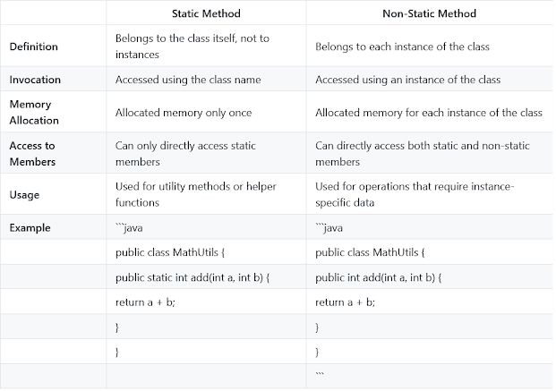

**THIS KEYWORD:**

this is a **reference variable** that refers to the current object.

1. [this can be used to refer current class instance variable.](https://www.javatpoint.com/this1)
2. [this can be used to invoke current class method (implicitly)](https://www.javatpoint.com/this2)
3. [this() can be used to invoke current class constructor.](https://www.javatpoint.com/this3)
4. [this can be passed as an argument in the method call.](https://www.javatpoint.com/this4)
5. [this can be passed as argument in the constructor call.](https://www.javatpoint.com/this5)
6. [this can be used to return the current class instance from the method.](https://www.javatpoint.com/this6)

**JAVA COMPARABLE AND COMPARATOR INTERFACE:**

**Comparable :** Java Comparable interface is used to order the objects of the user-defined class. contains only one method named compareTo(Object). It provides a single sorting sequence only

**public int compareTo(Object obj):** It is used to compare the current object with the specified object. It returns

* positive integer, if the current object is greater than the specified object.
* negative integer, if the current object is less than the specified object.
* zero, if the current object is equal to the specified object.

**Example:**

1. **class** Student **implements** Comparable<Student>{
2. **int** rollno;
3. String name;
4. **int** age;
5. Student(**int** rollno,String name,**int** age){
6. **this**.rollno=rollno;
7. **this**.name=name;
8. **this**.age=age;
9. }
11. **public** **int** compareTo(Student st){
12. **if**(age==st.age)
13. **return** 0;
14. **else** **if**(age>st.age)
15. **return** 1;
16. **else**
17. **return** -1;
18. }
19. }

*File: TestSort1.java*

1. **import** java.util.*;
2. **public** **class** TestSort1{
3. **public** **static** **void** main(String args[]){
4. ArrayList<Student> al=**new** ArrayList<Student>();
5. al.add(**new** Student(101,"Vijay",23));
6. al.add(**new** Student(106,"Ajay",27));
7. al.add(**new** Student(105,"Jai",21));
9. Collections.sort(al);
10. **for**(Student st:al){
11. System.out.println(st.rollno+" "+st.name+" "+st.age);
12. }
13. }
14. }

**Comparator Interface:**  is used to order the objects of a user-defined class. contains 2 methods compare(Object obj1,Object obj2) and equals(Object element). It provides multiple sorting sequences, i.e., you can sort the elements on the basis of any data member, for example, rollno, name, age or anything else.

1. **import** java.util.*;
2. **class** NameComparator **implements** Comparator{
3. **public** **int** compare(Object o1,Object o2){
4. Student s1=(Student)o1;
5. Student s2=(Student)o2;
7. **return** s1.name.compareTo(s2.name);
8. }
9. }

**Simple.java**

In this class, we are printing the values of the object by sorting on the basis of name and age.

1. **import** java.util.*;
2. **import** java.io.*;
4. **class** Simple{
5. **public** **static** **void** main(String args[]){
7. ArrayList al=**new** ArrayList();
8. al.add(**new** Student(101,"Vijay",23));
9. al.add(**new** Student(106,"Ajay",27));
10. al.add(**new** Student(105,"Jai",21));
12. System.out.println("Sorting by Name");
14. Collections.sort(al,**new** NameComparator());
15. Iterator itr=al.iterator();
16. **while**(itr.hasNext()){
17. Student st=(Student)itr.next();
18. System.out.println(st.rollno+" "+st.name+" "+st.age);
19. }
21. System.out.println("Sorting by age");
23. Collections.sort(al,**new** AgeComparator());
24. Iterator itr2=al.iterator();
25. **while**(itr2.hasNext()){
26. Student st=(Student)itr2.next();
27. System.out.println(st.rollno+" "+st.name+" "+st.age);
28. }

31. }
32. }

|  |  |
| --- | --- |
| **Comparable** | **Comparator** |
| 1) Comparable provides a **single sorting sequence**. In other words, we can sort the collection on the basis of a single element such as id, name, and price. | The Comparator provides **multiple sorting sequences**. In other words, we can sort the collection on the basis of multiple elements such as id, name, and price etc. |
| 2) Comparable **affects the original class**, i.e., the actual class is modified. | Comparator **doesn't affect the original class**, i.e., the actual class is not modified. |
| 3) Comparable provides **compareTo() method** to sort elements. | Comparator provides **compare() method** to sort elements. |
| 4) Comparable is present in **java.lang** package. | A Comparator is present in the **java.util** package. |
| 5) We can sort the list elements of Comparable type by **Collections.sort(List)** method. | We can sort the list elements of Comparator type by **Collections.sort(List, Comparator)** method. |

**Exception Handling:**

an exception is an event that disrupts the normal flow of the program. It is an object which is thrown at runtime.

Types: Checked , Unchecked, Error

* **Checked Exceptions:** IOException, SQLException, ClassNotFoundException
* **Unchecked Exceptions:** NullPointerException, ArrayIndexOutOfBoundsException, ArithmeticException

### **1) Checked Exception**

The classes that directly inherit the Throwable class except RuntimeException and Error are known as checked exceptions. For example, IOException, SQLException, etc. Checked exceptions are checked at compile-time.

### **2) Unchecked Exception**

The classes that inherit the RuntimeException are known as unchecked exceptions. For example, ArithmeticException, NullPointerException, ArrayIndexOutOfBoundsException, etc. Unchecked exceptions are not checked at compile-time, but they are checked at runtime.

### **3) Error**

Error is irrecoverable. Some example of errors are OutOfMemoryError, VirtualMachineError, AssertionError etc.

Example:

1. **public** **class** JavaExceptionExample{
2. **public** **static** **void** main(String args[]){
3. **try**{
4. //code that may raise exception
5. **int** data=100/0;
6. }**catch**(ArithmeticException e){System.out.println(e);}
7. //rest code of the program
8. System.out.println("rest of the code...");
9. }
10. }

Multiple Catch Block exception:

1. **public** **class** MultipleCatchBlock1 {
3. **public** **static** **void** main(String[] args) {
5. **try**{
6. **int** a[]=**new** **int**[5];
7. a[5]=30/0;
8. }
9. **catch**(ArithmeticException e)
10. {
11. System.out.println("Arithmetic Exception occurs");
12. }
13. **catch**(ArrayIndexOutOfBoundsException e)
14. {
15. System.out.println("ArrayIndexOutOfBounds Exception occurs");
16. }
17. **catch**(Exception e)
18. {
19. System.out.println("Parent Exception occurs");
20. }
21. System.out.println("rest of the code");
22. }
23. }

Finally Block:

Java finally block is always executed whether an exception is handled or not. Therefore, it contains all the necessary statements that need to be printed regardless of the exception occurs or not.

Java throw keyword: is used to throw an exception explicitly.

Example:

1. **public** **class** TestThrow1 {
2. //function to check if person is eligible to vote or not
3. **public** **static** **void** validate(**int** age) {
4. **if**(age<18) {
5. //throw Arithmetic exception if not eligible to vote
6. **throw** **new** ArithmeticException("Person is not eligible to vote");
7. }
8. **else** {
9. System.out.println("Person is eligible to vote!!");
10. }
11. }
12. //main method
13. **public** **static** **void** main(String args[]){
14. //calling the function
15. validate(13);
16. System.out.println("rest of the code...");
17. }
18. }

Java throws keyword:

The **Java throws keyword** is used to declare an exception. It gives an information to the programmer that there may occur an exception. So, it is better for the programmer to provide the exception handling code so that the normal flow of the program can be maintained.

Example:

1. i**mport** java.io.*;
2. **class** M{
3. **void** method()**throws** IOException{
4. **throw** **new** IOException("device error");
5. }
6. }
7. **public** **class** Testthrows2{
8. **public** **static** **void** main(String args[]){
9. **try**{
10. M m=**new** M();
11. m.method();
12. }**catch**(Exception e){System.out.println("exception handled");}
14. System.out.println("normal flow...");
15. }
16. }

|  |  |  |  |
| --- | --- | --- | --- |
| **Sr. no.** | **Basis of Differences** | **throw** | **throws** |
| 1. | Definition | Java throw keyword is used throw an exception explicitly in the code, inside the function or the block of code. | Java throws keyword is used in the method signature to declare an exception which might be thrown by the function while the execution of the code. |
| 2. | Type of exception Using throw keyword, we can only propagate unchecked exception i.e., the checked exception cannot be propagated using throw only. | Using throws keyword, we can declare both checked and unchecked exceptions. However, the throws keyword can be used to propagate checked exceptions only. |  |
| 3. | Syntax | The throw keyword is followed by an instance of Exception to be thrown. | The throws keyword is followed by class names of Exceptions to be thrown. |
| 4. | Declaration | throw is used within the method. | throws is used with the method signature. |
| 5. | Internal implementation | We are allowed to throw only one exception at a time i.e. we cannot throw multiple exceptions. | We can declare multiple exceptions using throws keyword that can be thrown by the method. For example, main() throws IOException, SQLException. |

Difference between final finally and finalise

|  |  |  |  |  |
| --- | --- | --- | --- | --- |
| **Sr. no.** | **Key** | **final** | **finally** | **finalize** |
| 1. | Definition | final is the keyword and access modifier which is used to apply restrictions on a class, method or variable. | finally is the block in Java Exception Handling to execute the important code whether the exception occurs or not. | finalize is the method in Java which is used to perform clean up processing just before object is garbage collected. |
| 2. | Applicable to | Final keyword is used with the classes, methods and variables. | Finally block is always related to the try and catch block in exception handling. | finalize() method is used with the objects. |
| 3. | Functionality | (1) Once declared, final variable becomes constant and cannot be modified. (2) final method cannot be overridden by sub class. (3) final class cannot be inherited. | (1) finally block runs the important code even if exception occurs or not. (2) finally block cleans up all the resources used in try block | finalize method performs the cleaning activities with respect to the object before its destruction. |
| 4. | Execution | Final method is executed only when we call it. | Finally block is executed as soon as the try-catch block is executed.  It's execution is not dependant on the exception. | finalize method is executed just before the object is destroyed. |

**Java custom Exception:**

1. **public** **class** WrongFileNameException **extends** Exception {
2. **public** WrongFileNameException(String errorMessage) {
3. **super**(errorMessage);
4. }
5. }

**What makes a HashSet different from a TreeSet?**

Although both HashSet and TreeSet are not synchronized and ensure that duplicates are not present, there are certain properties that distinguish a HashSet from a TreeSet.

* **Implementation:** For a HashSet, the hash table is utilized for storing the elements in an unordered manner. Howjdkever, TreeSet makes use of the red-black tree to store the elements in a sorted manner.
* **Complexity/ Performance:** For adding, retrieving, and deleting elements, the time amortized complexity is O(1) for a HashSet. The time complexity for performing the same operations is a bit higher for TreeSet and is equal to O(log n). Overall, the performance of HashSet is faster in comparison to TreeSet.
* **Methods:**hashCode() and equals() are the methods utilized by HashSet for making comparisons between the objects. Conversely, compareTo() and compare() methods are utilized by TreeSet to facilitate object comparisons.
* **Objects type:** Heterogeneous and null objects can be stored with the help of HashSet. In the case of a TreeSet, runtime exception occurs while inserting heterogeneous objects or null objects.

**JAVA8 FEATURES:**

**1.Lambda Expression:**

The Lambda expression is used to provide the implementation of an interface which has functional interface. It saves a lot of code. In case of lambda expression, we don't need to define the method again for providing the implementation

Use: To provide the implementation of Functional interface, Less coding.

1. Syntax: (argument-list) -> {body}

Java lambda expression is consisted of three components.

**1) Argument-list:** It can be empty or non-empty as well.

**2) Arrow-token:** It is used to link arguments-list and body of expression.

**3) Body:** It contains expressions and statements for lambda expression.

1. Example:
2. @FunctionalInterface  //It is optional
3. **interface** Drawable{
4. **public** **void** draw();
5. }
7. **public** **class** LambdaExpressionExample2 {
8. **public** **static** **void** main(String[] args) {
9. **int** width=10;
11. //with lambda
12. Drawable d2=()->{
13. System.out.println("Drawing "+width);
14. };
15. d2.draw();
16. }
17. }

Example: Using forEach:

1. **import** java.util.*;
2. **public** **class** LambdaExpressionExample7{
3. **public** **static** **void** main(String[] args) {
5. List<String> list=**new** ArrayList<String>();
6. list.add("ankit");
7. list.add("mayank");
8. list.add("irfan");
9. list.add("jai");
11. list.forEach(
12. (n)->System.out.println(n)
13. );
14. }
15. }

**2FUNCTIONAL INTERFACE:**

An Interface that contains exactly one abstract method is known as functional interface. It can have any number of default, static methods but can contain only one abstract method. It can also declare methods of object class.

Functional Interface is also known as Single Abstract Method Interfaces or SAM Interfaces. It is a new feature in Java, that helps to achieve functional programming approach.

The introduction of functional interfaces in Java 8 was a game changer, giving developers a more concise and transparent way of writing code. These interactions paved the way for the adoption of design strategies that work within the Java ecosystem.

It serves as a blueprint for implementing lambda expressions or method references. By restricting the interface to a single abstract method, Java ensures that it qualifies as a functional interface, allowing one to use it in functional programming paradigms.

**File Name: FunctionalInterfaceExample.java**

1. @FunctionalInterface
2. **interface** sayable{
3. **void** say(String msg);
4. }
5. **public** **class** FunctionalInterfaceExample **implements** sayable{
6. **public** **void** say(String msg){
7. System.out.println(msg);
8. }
9. **public** **static** **void** main(String[] args) {
10. FunctionalInterfaceExample fie = **new** FunctionalInterfaceExample();
11. fie.say("Hello there");
12. }
13. }

## **Java Predefined-Functional Interfaces**

Java 8 introduced several built-in functional interfaces in the java.util.function package, each designed to support common functional programming patterns. Some of the most commonly used functional interfaces include:

| **Functional Interface** | **Description** | **Abstract Method** |
| --- | --- | --- |
| Predicate<T> | Checks a condition and returns true or false | test(T t) |
| Function<T, R> | Takes input T and returns output R | apply(T t) |
| Consumer<T> | Takes input T and performs an action (no return) | accept(T t) |
| Supplier<T> | Provides a result without any input | get() |
| UnaryOperator<T> | A function where input and output types are the same (T → T) | apply(T t) |
| BinaryOperator<T> | A function that takes two inputs of the same type and returns the same type | apply(T t1, T t2) |
| BiPredicate<T, U> | A Predicate with two arguments | test(T t, U u) |
| BiFunction<T, U, R> | A Function with two arguments | apply(T t, U u) |
| BiConsumer<T, U> | A Consumer that takes two arguments | accept(T t, U u) |

**Supplier:** Represents a supplier of results.  
• **Provides a value without taking any input.**

•

| **Method** | **Description** |
| --- | --- |
| get() | Returns a value. |

Example: Generating a random number.  
import java.util.function.Supplier;

public class SupplierExample {

public static void main(String[] args) {

Supplier<Double> randomSupplier = () -> Math.random();

System.out.println(randomSupplier.get());

}

}

**Consumer:** Represents an operation that accepts a single input argument and returns no result.  
Takes an input and performs an operation, but does not return anything.

| **Method** | **Description** |
| --- | --- |
| accept(T t) | Performs an action on the input. |
| andThen(Consumer after) | Chains multiple consumers. |

Example: Printing a message.  
import java.util.function.Consumer;

public class ConsumerExample {

public static void main(String[] args) {

Consumer<String> printMessage = message -> System.out.println("Message: " + message);

printMessage.accept("Hello, World!");

}

}

**Predicate:** Represents a predicate (boolean-valued function) of one argument.

Used for conditional checks (returns true or false).  
**Methods in Predicate**

| **Method** | **Description** |
| --- | --- |
| test(T t) | Evaluates this predicate on the given argument. |
| and(Predicate other) | Combines predicates using AND logic. |
| or(Predicate other) | Combines predicates using OR logic. |
| negate() | Returns the negation of the predicate. |

example : import java.util.function.Predicate;

public class PredicateExample {

public static void main(String[] args) {

Predicate<Integer> isEven = num -> num % 2 == 0

System.out.println(isEven.test(10)); // Output: true

System.out.println(isEven.test(7)); // Output: false

}

}

**Function:** Represents a function that accepts one argument and produces a result.

• **Takes an input T and returns output R.**

• Example: Getting the length of a string.

import java.util.function.Function;

public class FunctionExample {

public static void main(String[] args) {

Function<String, Integer> getLength = str -> str.length();

System.out.println(getLength.apply("Java")); // Output: 4

}

}

| **Method** | **Description** |
| --- | --- |
| apply(T t) | Applies the function to an input. |
| compose(Function before) | First applies before, then applies this function. |
| andThen(Function after) | First applies this function, then applies after. |
| identity() | Returns a function that returns its input. |

**UnaryOperator:** Represents an operation on a single operand that produces a result of the same type as its operand.  
• **Same as Function<T, R> but input and output types are the same.**

• Example: Squaring a number.

import java.util.function.UnaryOperator;

public class UnaryOperatorExample {

public static void main(String[] args) {

UnaryOperator<Integer> square = num -> num * num;

System.out.println(square.apply(5)); // Output: 25

}

}

**BinaryOperator:** Represents an operation upon two operands of the same type, producing a result of the same type as the operands.  
• **Similar to UnaryOperator, but takes two arguments.**

• Example: Adding two numbers.

import java.util.function.BinaryOperator;

public class BinaryOperatorExample {

public static void main(String[] args) {

BinaryOperator<Integer> add = (a, b) -> a + b;

System.out.println(add.apply(10, 20)); // Output: 30

}

}

These functional interfaces provide a foundation for writing functional-style code in Java. They encapsulate common patterns and enable developers to write more concise and readable code.

**3.STREAM API:**

* Stream does not store elements. It simply conveys elements from a source such as a data structure, an array, or an I/O channel, through a pipeline of computational operations.
* Stream is functional in nature. Operations performed on a stream does not modify it's source. For example, filtering a Stream obtained from a collection produces a new Stream without the filtered elements, rather than removing elements from the source collection.
* Stream is lazy and evaluates code only when required.
* The elements of a stream are only visited once during the life of a stream. Like an Iterator, a new stream must be generated to revisit the same elements of the source.

**4.ForEach() method:**

Java provides a new method forEach() to iterate the elements. It is defined in Iterable and Stream interface.

Example:

1. **import** java.util.ArrayList;
2. **import** java.util.List;
3. **public** **class** ForEachExample {
4. **public** **static** **void** main(String[] args) {
5. List<String> gamesList = **new** ArrayList<String>();
6. gamesList.add("Football");
7. gamesList.add("Cricket");
8. gamesList.add("Chess");
9. gamesList.add("Hocky");
10. System.out.println("------------Iterating by passing lambda expression--------------");
11. gamesList.forEach(games -> System.out.println(games));
13. }
14. }

**5.Optional Class:**

1. **import** java.util.Optional;
2. **public** **class** OptionalExample {
3. **public** **static** **void** main(String[] args) {
4. String[] str = **new** String[10];
5. Optional<String> checkNull = Optional.ofNullable(str[5]);
6. **if**(checkNull.isPresent()){  // check for value is present or not
7. String lowercaseString = str[5].toLowerCase();
8. System.out.print(lowercaseString);
9. }**else**
10. System.out.println("string value is not present");
11. }
12. }

**COLLECTION:**

The **Collection in Java** is a framework that provides an architecture to store and manipulate the group of objects.Java Collections can achieve all the operations that you perform on a data such as searching, sorting, insertion, manipulation, and deletion.Java Collection means a single unit of objects. Java Collection framework provides many interfaces (Set, List, Queue, Deque) and classes ([ArrayList](https://www.javatpoint.com/java-arraylist), Vector, [LinkedList](https://www.javatpoint.com/java-linkedlist), [PriorityQueue](https://www.javatpoint.com/java-priorityqueue), HashSet, LinkedHashSet, TreeSet).

ARRAYLIST:

* Java ArrayList class can contain duplicate elements.
* Java ArrayList class maintains insertion order.
* Java ArrayList class is non [synchronized](https://www.javatpoint.com/synchronization-in-java).
* Java ArrayList allows random access because the array works on an index basis.
* In ArrayList, manipulation is a little bit slower than the LinkedList in Java because a lot of shifting needs to occur if any element is removed from the array list.
* We can not create an array list of the primitive types, such as int, float, char, etc. It is required to use the required wrapper class in such cases. For example:

Example:

1. **import** java.util.*;
2. **public** **class** ArrayListExample3{
3. **public** **static** **void** main(String args[]){
4. ArrayList<String> list=**new** ArrayList<String>();//Creating arraylist
5. list.add("Mango");//Adding object in arraylist
6. list.add("Apple");
7. list.add("Banana");
8. list.add("Grapes");
9. //Traversing list through for-each loop
10. **for**(String fruit:list)
11. System.out.println(fruit);
13. }
14. }
15. **import** java.util.*;
16. **class** Book {
17. **int** id;
18. String name,author,publisher;
19. **int** quantity;
20. **public** Book(**int** id, String name, String author, String publisher, **int** quantity) {
21. **this**.id = id;
22. **this**.name = name;
23. **this**.author = author;
24. **this**.publisher = publisher;
25. **this**.quantity = quantity;
26. }
27. }
28. **public** **class** ArrayListExample20 {
29. **public** **static** **void** main(String[] args) {
30. //Creating list of Books
31. List<Book> list=**new** ArrayList<Book>();
32. //Creating Books
33. Book b1=**new** Book(101,"Let us C","Yashwant Kanetkar","BPB",8);
34. Book b2=**new** Book(102,"Data Communications and Networking","Forouzan","Mc Graw Hill",4);
35. Book b3=**new** Book(103,"Operating System","Galvin","Wiley",6);
36. //Adding Books to list
37. list.add(b1);
38. list.add(b2);
39. list.add(b3);
40. //Traversing list
41. **for**(Book b:list){
42. System.out.println(b.id+" "+b.name+" "+b.author+" "+b.publisher+" "+b.quantity);
43. }
44. }
45. }

LINKED LIST:

* In Java LinkedList class, manipulation is fast because no shifting needs to occur.

Rest all is same as the arrayList

1. **import** java.util.*;
2. **class** Book {
3. **int** id;
4. String name,author,publisher;
5. **int** quantity;
6. **public** Book(**int** id, String name, String author, String publisher, **int** quantity) {
7. **this**.id = id;
8. **this**.name = name;
9. **this**.author = author;
10. **this**.publisher = publisher;
11. **this**.quantity = quantity;
12. }
13. }
14. **public** **class** LinkedListExample {
15. **public** **static** **void** main(String[] args) {
16. //Creating list of Books
17. List<Book> list=**new** LinkedList<Book>();
18. //Creating Books
19. Book b1=**new** Book(101,"Let us C","Yashwant Kanetkar","BPB",8);
20. Book b2=**new** Book(102,"Data Communications & Networking","Forouzan","Mc Graw Hill",4);
21. Book b3=**new** Book(103,"Operating System","Galvin","Wiley",6);
22. //Adding Books to list
23. list.add(b1);
24. list.add(b2);
25. list.add(b3);
26. //Traversing list
27. **for**(Book b:list){
28. System.out.println(b.id+" "+b.name+" "+b.author+" "+b.publisher+" "+b.quantity);
29. }
30. }
31. }
32. **import** java.util.*;
33. **class** Book {
34. **int** id;
35. String name,author,publisher;
36. **int** quantity;
37. **public** Book(**int** id, String name, String author, String publisher, **int** quantity) {
38. **this**.id = id;
39. **this**.name = name;
40. **this**.author = author;
41. **this**.publisher = publisher;
42. **this**.quantity = quantity;
43. }
44. }
45. **public** **class** ListExample5 {
46. **public** **static** **void** main(String[] args) {
47. //Creating list of Books
48. List<Book> list=**new** ArrayList<Book>();
49. //Creating Books
50. Book b1=**new** Book(101,"Let us C","Yashwant Kanetkar","BPB",8);
51. Book b2=**new** Book(102,"Data Communications and Networking","Forouzan","Mc Graw Hill",4);
52. Book b3=**new** Book(103,"Operating System","Galvin","Wiley",6);
53. //Adding Books to list
54. list.add(b1);
55. list.add(b2);
56. list.add(b3);
57. //Traversing list
58. **for**(Book b:list){
59. System.out.println(b.id+" "+b.name+" "+b.author+" "+b.publisher+" "+b.quantity);
60. }
61. }
62. }

LIST INTERFACE:

Ordered elements , stores null elements, maintain insertion order, duplicate elements.

It uses arrayList and LinkedList for its implementation.

ListIterator interface: to traverse the elements in backward and forward direction

| **List** | **Set** |
| --- | --- |
| 1. The List is an indexed sequence. | 1. The Set is an non-indexed sequence. |
| 2. List allows duplicate elements | 2. Set doesn’t allow duplicate elements. |
| 3. Elements by their position can be accessed. | 3. Position access to elements is not allowed. |
| 4. Multiple null elements can be stored. | 4. Null element can store only once. |
| 5. List implementations are ArrayList, LinkedList, Vector, Stack | 5. Set implementations are HashSet, LinkedHashSet. |

**JAVA HASHSET:**

Java HashSet class is used to create a collection that uses a hash table for storage.

* HashSet stores the elements by using a mechanism called **hashing.**
* HashSet contains unique elements only.
* HashSet allows null value.
* HashSet class is non synchronized.
* HashSet doesn't maintain the insertion order. Here, elements are inserted on the basis of their hashcode.
* HashSet is the best approach for search operations.
* The initial default capacity of HashSet is 16, and the load factor is 0.75.

**What is loadfactor?**

**Measures that decides when to increase the hashtable capacity to maintain the search and insert operation**

1. **import** java.util.*;
2. **class** Book {
3. **int** id;
4. String name,author,publisher;
5. **int** quantity;
6. **public** Book(**int** id, String name, String author, String publisher, **int** quantity) {
7. **this**.id = id;
8. **this**.name = name;
9. **this**.author = author;
10. **this**.publisher = publisher;
11. **this**.quantity = quantity;
12. }
13. }
14. **public** **class** HashSetExample {
15. **public** **static** **void** main(String[] args) {
16. HashSet<Book> set=**new** HashSet<Book>();
17. //Creating Books
18. Book b1=**new** Book(101,"Let us C","Yashwant Kanetkar","BPB",8);
19. Book b2=**new** Book(102,"Data Communications & Networking","Forouzan","Mc Graw Hill",4);
20. Book b3=**new** Book(103,"Operating System","Galvin","Wiley",6);
21. //Adding Books to HashSet
22. set.add(b1);
23. set.add(b2);
24. set.add(b3);
25. //Traversing HashSet
26. **for**(Book b:set){
27. System.out.println(b.id+" "+b.name+" "+b.author+" "+b.publisher+" "+b.quantity);
28. }
29. }
30. }

**LINKED HASHSET:**

**J**ava LinkedHashSet class is a Hashtable and Linked list implementation of the Set interface.

* Java LinkedHashSet class contains unique elements only like HashSet.
* Java LinkedHashSet class provides all optional set operations and permits null elements.
* Java LinkedHashSet class is non-synchronized.
* Java LinkedHashSet class maintains insertion order.
* **import** java.util.*;
* **class** Book {
* **int** id;
* String name,author,publisher;
* **int** quantity;
* **public** Book(**int** id, String name, String author, String publisher, **int** quantity) {
* **this**.id = id;
* **this**.name = name;
* **this**.author = author;
* **this**.publisher = publisher;
* **this**.quantity = quantity;
* }
* }
* **public** **class** LinkedHashSetExample {
* **public** **static** **void** main(String[] args) {
* LinkedHashSet<Book> hs=**new** LinkedHashSet<Book>();
* //Creating Books
* Book b1=**new** Book(101,"Let us C","Yashwant Kanetkar","BPB",8);
* Book b2=**new** Book(102,"Data Communications & Networking","Forouzan","Mc Graw Hill",4);
* Book b3=**new** Book(103,"Operating System","Galvin","Wiley",6);
* //Adding Books to hash table
* hs.add(b1);
* hs.add(b2);
* hs.add(b3);
* //Traversing hash table
* **for**(Book b:hs){
* System.out.println(b.id+" "+b.name+" "+b.author+" "+b.publisher+" "+b.quantity);
* }
* }
* }

**TREESET:**

Java TreeSet class implements the Set interface that uses a tree for storage.

* Java TreeSet class contains unique elements only like HashSet.
* Java TreeSet class access and retrieval times are quite fast.
* Java TreeSet class doesn't allow null elements.
* Java TreeSet class is non-synchronized.
* Java TreeSet class maintains ascending order.
* **import** java.util.*;
* **class** Book **implements** Comparable<Book>{
* **int** id;
* String name,author,publisher;
* **int** quantity;
* **public** Book(**int** id, String name, String author, String publisher, **int** quantity) {
* **this**.id = id;
* **this**.name = name;
* **this**.author = author;
* **this**.publisher = publisher;
* **this**.quantity = quantity;
* }
* // implementing the abstract method
* **public** **int** compareTo(Book b) {
* **if**(id>b.id){
* **return** 1;
* }**else** **if**(id<b.id){
* **return** -1;
* }**else**{
* **return** 0;
* }
* }
* }
* **public** **class** TreeSetExample {
* **public** **static** **void** main(String[] args) {
* Set<Book> set=**new** TreeSet<Book>();
* //Creating Books
* Book b1=**new** Book(121,"Let us C","Yashwant Kanetkar","BPB",8);
* Book b2=**new** Book(233,"Operating System","Galvin","Wiley",6);
* Book b3=**new** Book(101,"Data Communications & Networking","Forouzan","Mc Graw Hill",4);
* //Adding Books to TreeSet
* set.add(b1);
* set.add(b2);
* set.add(b3);
* //Traversing TreeSet
* **for**(Book b:set){
* System.out.println(b.id+" "+b.name+" "+b.author+" "+b.publisher+" "+b.quantity);
* }
* }
* }

**JAVA MAP INTERFACE:**

A map contains values on the basis of key, i.e. key and value pair. Each key and value pair is known as an entry. A Map contains unique keys.

A Map is useful if you have to search, update or delete elements on the basis of a key.

1. **import** java.util.*;
2. **class** MapExample4{
3. **public** **static** **void** main(String args[]){
4. Map<Integer,String> map=**new** HashMap<Integer,String>();
5. map.put(100,"Amit");
6. map.put(101,"Vijay");
7. map.put(102,"Rahul");
8. //Returns a Set view of the mappings contained in this map
9. map.entrySet()
10. //Returns a sequential Stream with this collection as its source
11. .stream()
12. //Sorted according to the provided Comparator
13. .sorted(Map.Entry.comparingByKey(Comparator.reverseOrder()))
14. //Performs an action for each element of this stream
15. .forEach(System.out::println);
16. }
17. }

**HASHMAP:**

* Java HashMap contains values based on the key.
* Java HashMap contains only unique keys.
* Java HashMap may have one null key and multiple null values.
* Java HashMap is non synchronized.
* Java HashMap maintains no order.
* **import** java.util.*;
* **class** Book {
* **int** id;
* String name,author,publisher;
* **int** quantity;
* **public** Book(**int** id, String name, String author, String publisher, **int** quantity) {
* **this**.id = id;
* **this**.name = name;
* **this**.author = author;
* **this**.publisher = publisher;
* **this**.quantity = quantity;
* }
* }
* **public** **class** MapExample {
* **public** **static** **void** main(String[] args) {
* //Creating map of Books
* Map<Integer,Book> map=**new** HashMap<Integer,Book>();
* //Creating Books
* Book b1=**new** Book(101,"Let us C","Yashwant Kanetkar","BPB",8);
* Book b2=**new** Book(102,"Data Communications & Networking","Forouzan","Mc Graw Hill",4);
* Book b3=**new** Book(103,"Operating System","Galvin","Wiley",6);
* //Adding Books to map
* map.put(1,b1);
* map.put(2,b2);
* map.put(3,b3);
* //Traversing map
* **for**(Map.Entry<Integer, Book> entry:map.entrySet()){
* **int** key=entry.getKey();
* Book b=entry.getValue();
* System.out.println(key+" Details:");
* System.out.println(b.id+" "+b.name+" "+b.author+" "+b.publisher+" "+b.quantity);
* }
* }
* }

**LINKED HASHMAP:**

* Java LinkedHashMap contains values based on the key.
* Java LinkedHashMap contains unique elements.
* Java LinkedHashMap may have one null key and multiple null values.
* Java LinkedHashMap is non synchronized.
* Java LinkedHashMap maintains insertion order.
* **import** java.util.*;
* **class** Book {
* **int** id;
* String name,author,publisher;
* **int** quantity;
* **public** Book(**int** id, String name, String author, String publisher, **int** quantity) {
* **this**.id = id;
* **this**.name = name;
* **this**.author = author;
* **this**.publisher = publisher;
* **this**.quantity = quantity;
* }
* }
* **public** **class** MapExample {
* **public** **static** **void** main(String[] args) {
* //Creating map of Books
* Map<Integer,Book> map=**new** LinkedHashMap<Integer,Book>();
* //Creating Books
* Book b1=**new** Book(101,"Let us C","Yashwant Kanetkar","BPB",8);
* Book b2=**new** Book(102,"Data Communications & Networking","Forouzan","Mc Graw Hill",4);
* Book b3=**new** Book(103,"Operating System","Galvin","Wiley",6);
* //Adding Books to map
* map.put(2,b2);
* map.put(1,b1);
* map.put(3,b3);
* //Traversing map
* **for**(Map.Entry<Integer, Book> entry:map.entrySet()){
* **int** key=entry.getKey();
* Book b=entry.getValue();
* System.out.println(key+" Details:");
* System.out.println(b.id+" "+b.name+" "+b.author+" "+b.publisher+" "+b.quantity);
* }
* }
* }

**TREEMAP:**

* Java TreeMap contains values based on the key. It implements the NavigableMap interface and extends AbstractMap class.
* Java TreeMap contains only unique elements.
* Java TreeMap cannot have a null key but can have multiple null values.
* Java TreeMap is non synchronized.
* Java TreeMap maintains ascending order.

|  |  |
| --- | --- |
| **HashMap** | **TreeMap** |
| 1) HashMap can contain one null key. | TreeMap cannot contain any null key. |
| 2) HashMap maintains no order. | TreeMap maintains ascending order. |

1. **import** java.util.*;
2. **class** Book {
3. **int** id;
4. String name,author,publisher;
5. **int** quantity;
6. **public** Book(**int** id, String name, String author, String publisher, **int** quantity) {
7. **this**.id = id;
8. **this**.name = name;
9. **this**.author = author;
10. **this**.publisher = publisher;
11. **this**.quantity = quantity;
12. }
13. }
14. **public** **class** MapExample {
15. **public** **static** **void** main(String[] args) {
16. //Creating map of Books
17. Map<Integer,Book> map=**new** TreeMap<Integer,Book>();
18. //Creating Books
19. Book b1=**new** Book(101,"Let us C","Yashwant Kanetkar","BPB",8);
20. Book b2=**new** Book(102,"Data Communications & Networking","Forouzan","Mc Graw Hill",4);
21. Book b3=**new** Book(103,"Operating System","Galvin","Wiley",6);
22. //Adding Books to map
23. map.put(2,b2);
24. map.put(1,b1);
25. map.put(3,b3);
27. //Traversing map
28. **for**(Map.Entry<Integer, Book> entry:map.entrySet()){
29. **int** key=entry.getKey();
30. Book b=entry.getValue();
31. System.out.println(key+" Details:");
32. System.out.println(b.id+" "+b.name+" "+b.author+" "+b.publisher+" "+b.quantity);
33. }
34. }
35. }

|  |  |  |  |  |  |  |
| --- | --- | --- | --- | --- | --- | --- |
|  | Insertion order | Ascending order | Null Values | Unique Values/Duplicate Values | Synchronizd | Values based on |
| ArrayList | yes |  | yes | Duplicate | No | Random aceess |
| LinkedList | yes |  | yes | Duplicate | No | Random aceess |
| hashSet | no |  | Yes but one | Unique | No | Hash code |
| TreeSet |  | yes | No | Unique | No |  |
| Hashmap | no |  | One null key/ multiple null values | Unique | No | key |
| TreeMap | no | yes | One null key/ multiple null values | Unique | No | key |

**Design patterns in java**

**Design patterns** are well-proven solutions to common software design problems. They represent best practices, optimized and reusable solutions that software developers can use to solve recurring issues in software development.

In Java, design patterns provide templates for writing robust, scalable, and maintainable code.

**Why Use Design Patterns?**

1. **Code Reusability**: Patterns promote reusable solutions that can be applied across different projects.
2. **Maintainability**: Patterns help organize and structure code for easier maintenance.
3. **Best Practices**: They are based on expert knowledge and industry-proven methods.
4. **Scalability**: Patterns ensure code scalability for growing projects.
5. **Communication**: Patterns provide a common language for developers to discuss solutions.

**Types of Design Patterns**

Design patterns are broadly categorized into three groups:

**1. Creational Patterns**

These patterns deal with object creation mechanisms, trying to create objects in a manner suitable for the situation.

* **Singleton**: Ensures only one instance of a class exists and provides a global access point.
  + Example: Database connection pool.
* **Factory Method**: Provides an interface to create objects, but lets subclasses decide which class to instantiate.
  + Example: Logger creation based on log levels.
* **Abstract Factory**: Creates families of related objects without specifying their concrete classes.
  + Example: GUI frameworks for creating different themes.
* **Builder**: Builds complex objects step by step.
  + Example: Constructing a Car object with different parts.
* **Prototype**: Creates objects by cloning an existing object.
  + Example: Copying game characters with similar attributes.

**2. Structural Patterns**

These patterns deal with the composition of classes and objects to form larger structures.

* **Adapter**: Converts the interface of a class into another interface clients expect.
  + Example: A mobile charger adapter converting different power voltages.
* **Bridge**: Decouples an abstraction from its implementation so that both can vary independently.
  + Example: Separating device types (TV, Radio) from their remote controls.
* **Composite**: Composes objects into tree structures to represent part-whole hierarchies.
  + Example: A file system with files and directories.
* **Decorator**: Adds new behavior to objects dynamically without modifying their structure.
  + Example: Adding encryption to a file stream.
* **Facade**: Provides a unified interface to a set of interfaces in a subsystem.
  + Example: Simplifying database interaction with a single API.
* **Proxy**: Provides a placeholder for controlling access to another object.
  + Example: Remote method invocation (RMI) proxy.
* **Flyweight**: Reduces memory usage by sharing common parts of objects.
  + Example: Sharing character glyphs in a text editor.

**3. Behavioral Patterns**

These patterns focus on communication between objects, how they interact, and their responsibilities.

* **Strategy**: Defines a family of algorithms and allows them to be interchangeable.
  + Example: Sorting algorithms like quick sort, merge sort, or bubble sort.
* **Observer**: Establishes a one-to-many dependency, where one object changes and all dependents are notified.
  + Example: Event listeners in GUIs.
* **Template Method**: Defines the skeleton of an algorithm in a method, deferring some steps to subclasses.
  + Example: Hook methods in abstract classes.
* **Command**: Encapsulates a request as an object, allowing for parameterization of methods.
  + Example: Undo/Redo functionality in text editors.
* **Chain of Responsibility**: Passes requests along a chain of handlers until a suitable handler processes it.
  + Example: Logging systems with different log levels.
* **State**: Allows an object to alter its behavior when its internal state changes.
  + Example: A traffic light controller.
* **Visitor**: Allows you to add new operations to existing object structures without modifying them.
  + Example: Tax calculation in financial applications.

**Real-Time Examples in Java**

1. **Singleton Pattern**:
   * Used in java.lang.Runtime or java.sql.Connection for ensuring a single instance.
2. **Factory Pattern**:
   * Used in java.util.Calendar or java.text.NumberFormat to create objects without specifying their exact class.
3. **Decorator Pattern**:
   * Used in java.io classes like BufferedReader and InputStream.
4. **Observer Pattern**:
   * Used in java.util.Observer and java.util.Observable (deprecated in Java 9).
5. **Proxy Pattern**:
   * Used in frameworks like Hibernate or Spring AOP for lazy loading or managing database transactions.

**How to Choose the Right Design Pattern?**

* **Understand the Problem**: Analyze the problem domain and constraints.
* **Match to Patterns**: Identify which pattern aligns with the problem structure.
* **Scalability Needs**: Consider future requirements and scalability.
* **Ease of Implementation**: Evaluate complexity and implementation cost.

Garbage Collection in Java:

In java, garbage collector means unreferenced objects.  
It is the process of reclaiming runtime unused memory automatically.IN other words, It is a way to destroy unused objects.

How to work Garbage Collection?  
The GC of JVM collects only those objects that are created by new keyword. So, if you have created new object without new keyword , you can use finalize method to perform cleanup processing.

 The Java Virtual Machine (JVM) automatically handles this process.

**Finalization**

Before destroying an object, the garbage collector calls the [finalize()](https://www.geeksforgeeks.org/finalize-method-in-java-and-how-to-override-it/)method to perform cleanup activities. The method is defined in the [Object class](https://www.geeksforgeeks.org/object-class-in-java/)as follows:

*@Override*

*protected void finalize() throws Throwable {*

*System.out.println("GC cleaning up...");*

*}*

**Note:**

* The finalize() method is called by Garbage Collector, not JVM.
* The default implementation of finalize() is empty, so overriding it is recommended for resource cleanup.
* The finalize() method is called only once per object.
* If an uncaught exception is thrown by the finalize() method, the exception is ignored, and the finalization of that object terminates.

**Key Concepts of Garbage Collection**

1. **Automatic Memory Management**:
   * Java's GC automatically handles object lifecycle, so developers don't need to manually allocate or deallocate memory (as in C/C++).
2. **Heap Memory**:
   * Java objects are stored in heap memory.
   * The heap is divided into **Young Generation**, **Old Generation**, and sometimes a **Permanent Generation/Metaspace** (depending on the JVM).
3. **Object Eligibility for GC**:
   * An object becomes eligible for GC when it is no longer referenced by any live thread or reachable by active references.

**JVM Memory Model for GC**

1. **Young Generation**:
   * Divided into:
     + **Eden Space**: Newly created objects are allocated here.
     + **Survivor Spaces (S0 and S1)**: Objects that survive garbage collection in the Eden space are moved here.
   * Frequent minor garbage collections occur here (called **Minor GC**).
2. **Old Generation**:
   * Stores long-lived objects that survive multiple GC cycles in the Young Generation.
   * Garbage collection in this space is called **Major GC** or **Full GC**.
3. **Metaspace**:
   * Stores class metadata, replacing the Permanent Generation in Java 8 and later.
   * Metaspace grows dynamically and is not part of the heap.

**How Garbage Collection Works**

The GC process uses **different algorithms** to clean up memory. Common steps and algorithms include:

**1. Mark-and-Sweep Algorithm:**

* **Mark Phase**: Identifies all live objects by traversing references starting from "roots" (e.g., local variables, static variables, etc.).
* Reachable objects are marked as live, while the rest are considered garbage.
* **Sweep Phase**: Reclaims memory occupied by objects that were not marked as live.

**2. Generational Garbage Collection**

* Based on the assumption that most objects die young.
* Divides the heap into generations:
  + **Young Generation**: Frequent and faster garbage collections.
  + **Old Generation**: Less frequent, more time-consuming collections.

**3. Compacting**

* After reclaiming unused memory, the remaining objects may be compacted to reduce fragmentation.

**Garbage Collectors in Java**

Java provides several types of garbage collectors, configurable via JVM options:

1. **Serial Garbage Collector** (-XX:+UseSerialGC):
   * A simple, single-threaded collector.
   * Suitable for applications with small datasets and single-threaded environments.
2. **Parallel Garbage Collector** (-XX:+UseParallelGC):
   * Uses multiple threads for garbage collection in the Young and Old Generations.
   * Best for multi-threaded applications with large datasets.
3. **Concurrent Mark-Sweep (CMS) Garbage Collector** (-XX:+UseConcMarkSweepGC):
   * Performs GC concurrently with the application to minimize pause times.
   * Suitable for applications requiring low-latency.
4. **G1 Garbage Collector** (-XX:+UseG1GC):
   * Divides the heap into regions and prioritizes regions with the most garbage for collection.
   * Designed for predictable pause times in large heap applications.
5. **Z Garbage Collector (ZGC)** (-XX:+UseZGC):
   * A low-latency collector that handles heaps ranging from a few MBs to terabytes.
   * Pause times are kept under 10ms.
6. **Shenandoah Garbage Collector** (-XX:+UseShenandoahGC):
   * Another low-pause-time garbage collector, competing with ZGC.

**Garbage Collection Triggers**

Garbage collection is triggered when:

1. The **Eden Space** in the Young Generation fills up (causing a Minor GC).
2. The Old Generation fills up (causing a Major GC).
3. The application explicitly calls System.gc() (though it is only a request to the JVM and may not be honored).

**Example of Object Eligibility for GC**

java

CopyEdit

public class GarbageCollectionExample {

public static void main(String[] args) {

// Object 1

String str1 = new String("Hello");

// Object 2

String str2 = new String("World");

// Now str2 points to the same object as str1

str2 = str1;

// Object 2 is now eligible for garbage collection

// as there is no reference to "World"

}

}

**JVM Tools to Monitor Garbage Collection**

1. **JConsole**: Provides a GUI for monitoring JVM performance, including GC activity.
2. **VisualVM**: Offers detailed insights into heap usage and GC logs.
3. **Garbage Collection Logs**:
   * Enable GC logging with flags like -XX:+PrintGCDetails and -Xlog:gc.

**Key JVM Flags for GC**

* -Xms<size>: Set initial heap size.
* -Xmx<size>: Set maximum heap size.
* -XX:+UseG1GC: Use the G1 Garbage Collector.
* -XX:MetaspaceSize=<size>: Set the initial Metaspace size.
* -XX:+PrintGCDetails: Print detailed GC logs.

**Advantages of Garbage Collection**

1. Reduces the likelihood of memory leaks.
2. Automates memory management, reducing developer errors.
3. Improves developer productivity.

**differentiate between a String, StringBuffer, and a StringBuilder?**

* **Storage area:** In string, the String pool serves as the storage area. For StringBuilder and StringBuffer, heap memory is the storage area.
* **Mutability:** A String is immutable, whereas both the StringBuilder and StringBuffer are mutable.
* **Efficiency:** It is quite slow to work with a String. However, StringBuilder is the fastest in performing operations. The speed of a StringBuffer is more than a String and less than a StringBuilder. (For example appending a character is fastest in StringBuilder and very slow in String because a new memory is required for the new String with appended character.)
* **Thread-safe:** In the case of a threaded environment, StringBuilder and StringBuffer are used whereas a String is not used. However, StringBuilder is suitable for an environment with a single thread, and a StringBuffer is suitable for multiple threads.

**What are the different ways of threads usage?**

* We can define and implement a thread in java using two ways:
  + **Extending the Thread class**

**class** **InterviewBitThreadExample** **extends** **Thread**{

**public** **void** **run**(){

System.out.println("Thread runs...");

}

**public** **static** **void** **main**(String args[]){

InterviewBitThreadExample ib = **new** InterviewBitThreadExample();

ib.start();

}

}

* **Implementing the Runnable interface**

**class** **InterviewBitThreadExample** **implements** **Runnable**{

**public** **void** **run**(){

System.out.println("Thread runs...");

}

**public** **static** **void** **main**(String args[]){

Thread ib = **new** Thread(**new** InterviewBitThreadExample());

ib.start();

}

}

* Implementing a thread using the method of Runnable interface is more preferred and advantageous as Java does not have support for multiple inheritances of classes.
* start() method is used for creating a separate call stack for the thread execution. Once the call stack is created, JVM calls the run() method for executing the thread in that call stack.

**What is a ClassLoader?**

* Java Classloader is the program that belongs to JRE (Java Runtime Environment). The task of ClassLoader is to load the required classes and interfaces to the JVM when required.
* **Example-** To get input from the console, we require the scanner class. And the Scanner class is loaded by the ClassLoader.

**What do you understand by Object Cloning and how do you achieve it in Java?**

* It is the process of creating an exact copy of any object. In order to support this, a java class has to implement the Cloneable interface of java.lang package and override the clone() method provided by the Object class the syntax of which is:

**protected** Object **clone**() **throws** CloneNotSupportedException{

**return** (Object)**super**.clone();

}

* In case the Cloneable interface is not implemented and just the method is overridden, it results in CloneNotSupportedException in Java

**What are shallow copy and deep copy in java?**

To copy the object's data, we have several methods like deep copy and shallow copy.

**Example -**

**class** **Rectangle**{

**int** length = 5;

**int** breadth = 3;

}

Object for this Rectangle class - **Rectangle obj1 = new Rectangle();**

* **Shallow copy** - The shallow copy only creates a new reference and points to the same object. Example - For Shallow copy, we can do this by -

Rectangle obj2 = obj1;

Now by doing this what will happen is the new reference is created with the name obj2 and that will point to the same memory location.

* **Deep Copy** - In a deep copy, we create a new object and copy the old object value to the new object. Example -

Rectangle obj3 = **new** Rectangle();

Obj3.length = obj1.length;

Obj3.breadth = obj1.breadth;

Both these objects will point to the memory location as stated below -

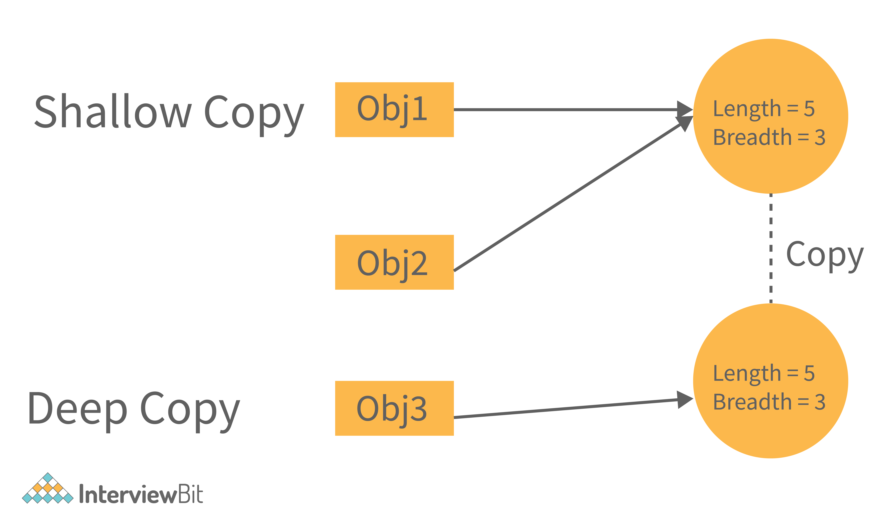

Now, if we change the values in shallow copy then they affect the other reference as well. Let's see with the help of an example -

**class** **Rectangle**

{

**int** length = 5;

**int** breadth = 3;

}

**public** **class** **Main**

{

**public** **static** **void** **main**(String[] args) {

Rectangle obj1 = **new** Rectangle();

//Shallow Copy

Rectangle obj2 = obj1;

System.out.println(" Before Changing the value of object 1, the object2 will be - ");

System.out.println(" Object2 Length = "+obj2.length+", Object2 Breadth = "+obj2.breadth);

//Changing the values for object1.

obj1.length = 10;

obj1.breadth = 20;

System.out.println("\n After Changing the value of object 1, the object2 will be - ");

System.out.println(" Object2 Length = "+obj2.length+", Object2 Breadth = "+obj2.breadth);

}

}

**Output -**

Before Changing the value of object 1, the object2 will be -

Object2 Length = 5, Object2 Breadth = 3

After Changing the value of object 1, the object2 will be -

Object2 Length = 10, Object2 Breadth = 20

We can see that in the above code, if we change the values of object1, then the object2 values also get changed. It is because of the reference.

Now, if we change the code to deep copy, then there will be no effect on object2 if it is of type deep copy. Consider some snippets to be added in the above code.

**class** **Rectangle**

{

**int** length = 5;

**int** breadth = 3;

}

**public** **class** **Main**

{

**public** **static** **void** **main**(String[] args) {

Rectangle obj1 = **new** Rectangle();

//Shallow Copy

Rectangle obj2 = **new** Rectangle();

obj2.length = obj1.length;

obj2.breadth = obj1.breadth;

System.out.println(" Before Changing the value of object 1, the object2 will be - ");

System.out.println(" Object2 Length = "+obj2.length+", Object2 Breadth = "+obj2.breadth);

//Changing the values for object1.

obj1.length = 10;

obj1.breadth = 20;

System.out.println("\n After Changing the value of object 1, the object2 will be - ");

System.out.println(" Object2 Length = "+obj2.length+", Object2 Breadth = "+obj2.breadth);

}

}

The above snippet will not affect the object2 values. It has its separate values.

**The output will be**

Before Changing the value of object 1, the object2 will be -

Object2 Length = 5, Object2 Breadth = 3

After Changing the value of object 1, the object2 will be –

Object2 Length = 5, Object2 Breadth = 3

_________________________________________________

Now we see that we need to write the number of codes for this deep copy. So to reduce this, In java, there is a method called **clone().**

The **clone()** will do this deep copy internally and return a new object. And to do this we need to write only 1 line of code. That is - **Rectangle obj2 = obj1.clone();**

**Fail Fast and Fail Safe Iterators in Java:**

**Fail-Fast Iterator**

* **Definition**: Immediately throws a ConcurrentModificationException if the collection is structurally modified after the iterator is created (except through the iterator's own methods).
* **Used In**: Most of the collections in java.util package like ArrayList, HashMap, HashSet.
* **Mechanism**: Uses a **modCount** variable to detect changes.
* **Thread Safety**: **Not thread-safe**.

**Example:**

**🛡️ Fail-Safe Iterator**

* **Definition**: Does **not throw** an exception if the collection is modified during iteration.
* **Used In**: Concurrent collections like CopyOnWriteArrayList, ConcurrentHashMap.
* **Mechanism**: Iterates over a **clone** or **snapshot** of the collection.
* **Thread Safety**: **Thread-safe**.

**Example:**

**🔍 Key Differences**

| **Feature** | **Fail-Fast** | **Fail-Safe** |
| --- | --- | --- |
| Exception on modification | Yes (ConcurrentModificationException) | No |
| Thread-safe | No | Yes |
| Performance | Faster | Slower (due to copying) |
| Used in | ArrayList, HashMap, etc. | ConcurrentHashMap, CopyOnWriteArrayList |
| Iterates over | Original collection | Cloned snapshot |

**Spring Framework Architecture:**

1. **Core Container:**
   * **Spring Core:** Provides the fundamental parts of the framework, including the IoC (Inversion of Control) and Dependency Injection features.
   * **Spring Beans:** Manages the beans (objects) in the application, handling their lifecycle and dependencies.
   * **Spring Context:** Builds on the Core and Beans modules, providing a way to access objects in a framework-style manner.
   * **Spring Expression Language (SpEL):** A powerful expression language for querying and manipulating an object graph at runtime.
2. **Data Access/Integration:**
   * **JDBC:** Simplifies database access with JDBC.
   * **ORM:** Supports integration with ORM frameworks like Hibernate, JPA, etc.
   * **OXM:** Provides Object/XML mapping implementations.
   * **JMS:** Simplifies the use of the Java Message Service (JMS).
   * **Transactions:** Manages transaction management in a consistent manner.
3. **Web:**
   * **Web:** Provides basic web-oriented integration features.
   * **Web-Servlet:** Contains Spring MVC, which is a robust and flexible framework for building web applications.
   * **Web-Struts:** Supports integration with the Struts framework.
   * **Web-Socket:** Provides support for WebSocket-based, two-way communication between client and server.
4. **AOP (Aspect-Oriented Programming):**
   * Provides support for aspect-oriented programming, allowing you to define method interceptors and pointcuts to decouple code.
5. **Instrumentation:**
   * Supports class instrumentation and classloader implementations to be used in certain application servers.
6. **Messaging:**
   * Provides support for STOMP as the WebSocket sub-protocol to use in applications.
7. **Test:**
   * Supports the testing of Spring components with JUnit or TestNG.

**Key Principles:**

* **Inversion of Control (IoC):** The control of object creation and management is transferred from the application code to the Spring container.
* **Dependency Injection (DI):** Dependencies are injected into objects, rather than objects creating or looking for dependencies.
* **Aspect-Oriented Programming (AOP):** Allows separation of cross-cutting concerns (like logging, security) from business logic.

**Java Immutable Class**

create immutable class by creating final class that have final data members  
In this example, we have created a final class named Employee. It have one final datamember, a parameterized constructor and getter method.

**ImmutableDemo.java**

1. **public** **final** **class** Employee
2. {
3. **final** String pancardNumber;
4. **public** Employee(String pancardNumber)
5. {
6. **this**.pancardNumber=pancardNumber;
7. }
8. **public** String getPancardNumber(){
9. **return** pancardNumber;
10. }
11. }
12. **public** **class** ImmutableDemo
13. {
14. **public** **static** **void** main(String ar[])
15. {
16. Employee e = **new** Employee("ABC123");
17. String s1 = e.getPancardNumber();
18. System.out.println("Pancard Number: " + s1);
19. }
20. }

**Output:**

*Pancard Number: ABC123*

The above class is immutable because:

* The instance variable of the class is final i.e. we cannot change the value of it after creating an object.
* The class is final so we cannot create the subclass.
* There is no setter methods i.e. we have no option to change the value of the instance variable.

These points makes this class as immutable.

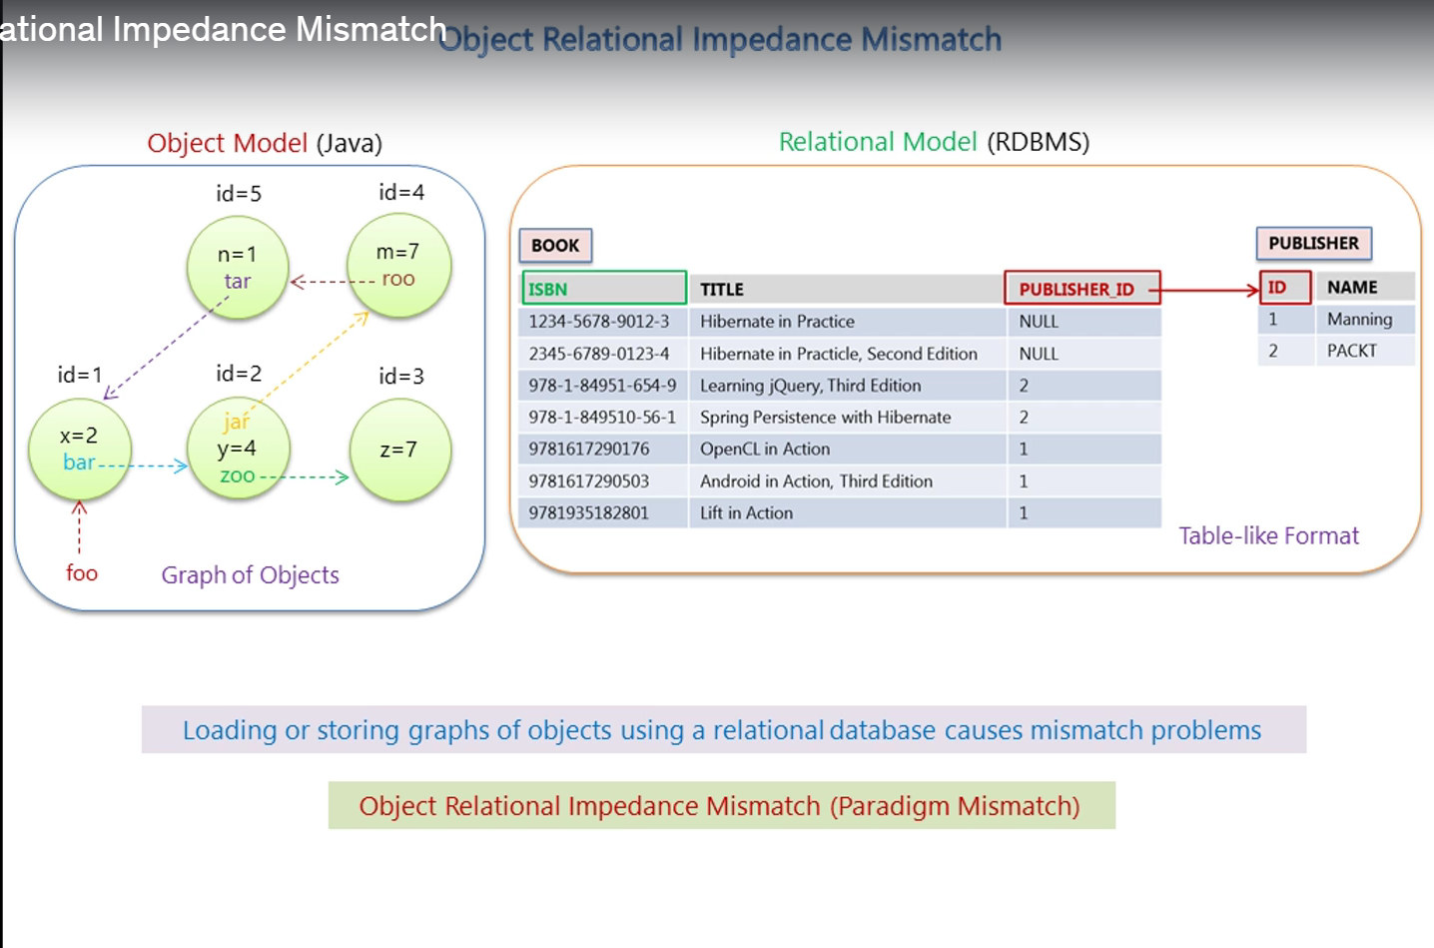  
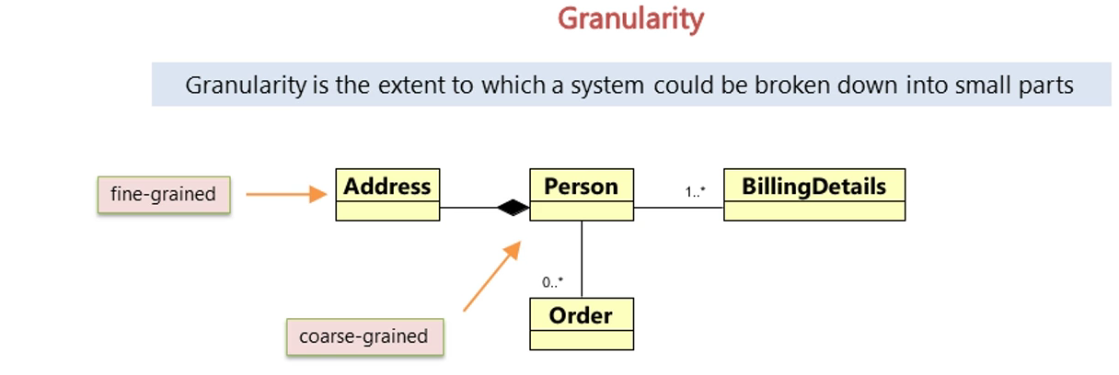  
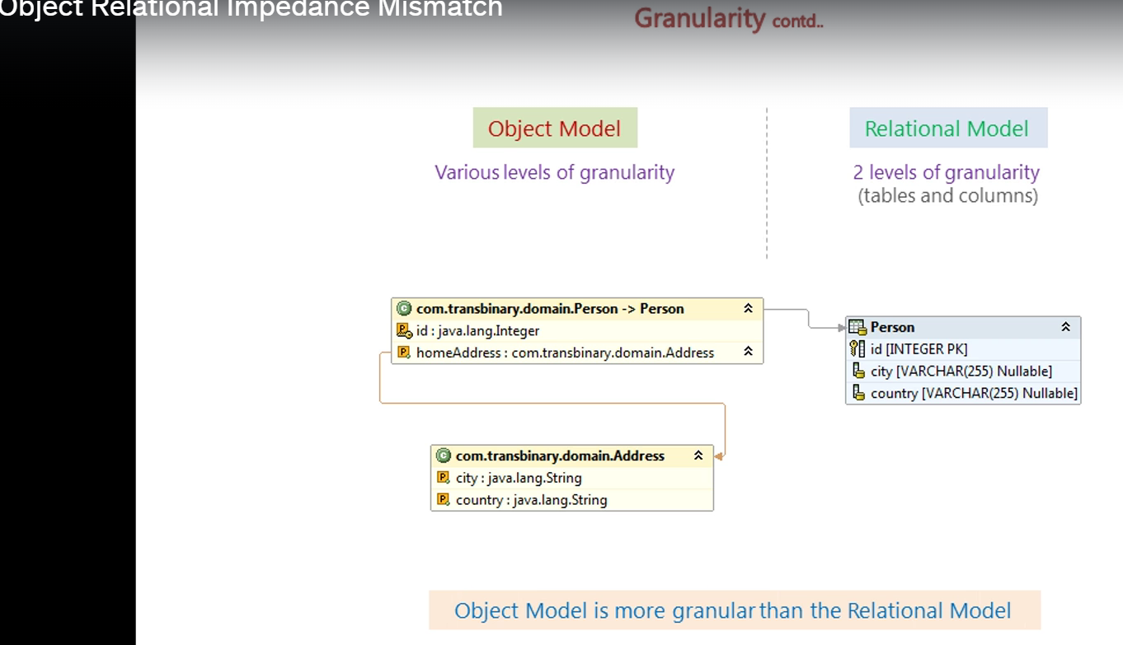

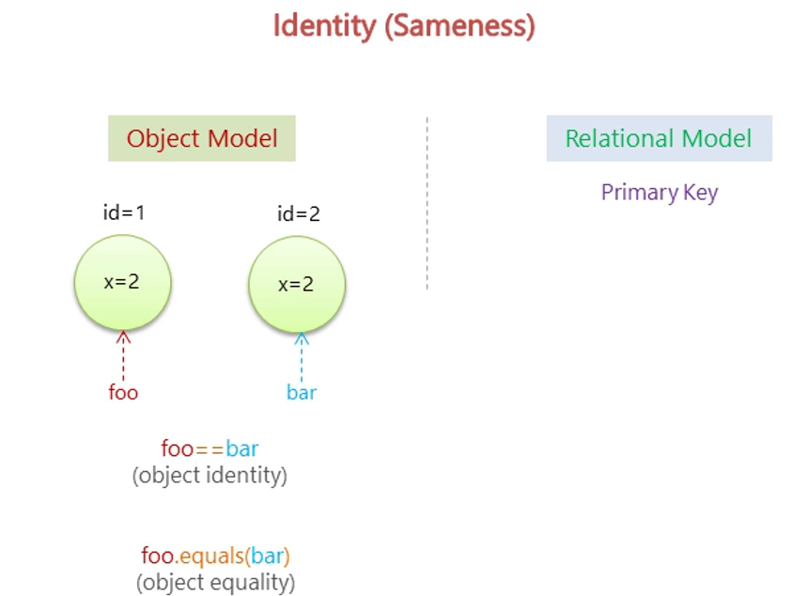  
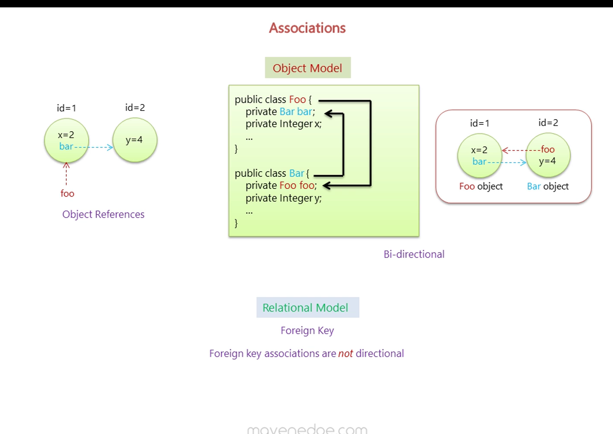

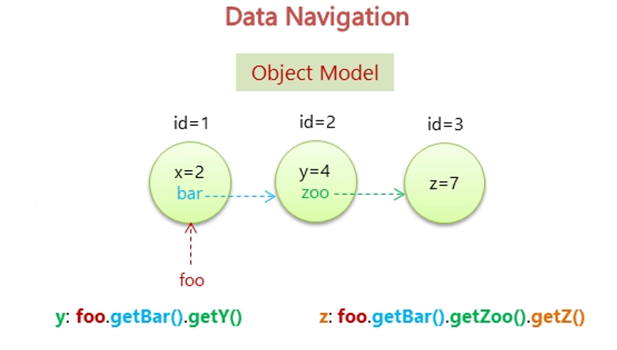  
  
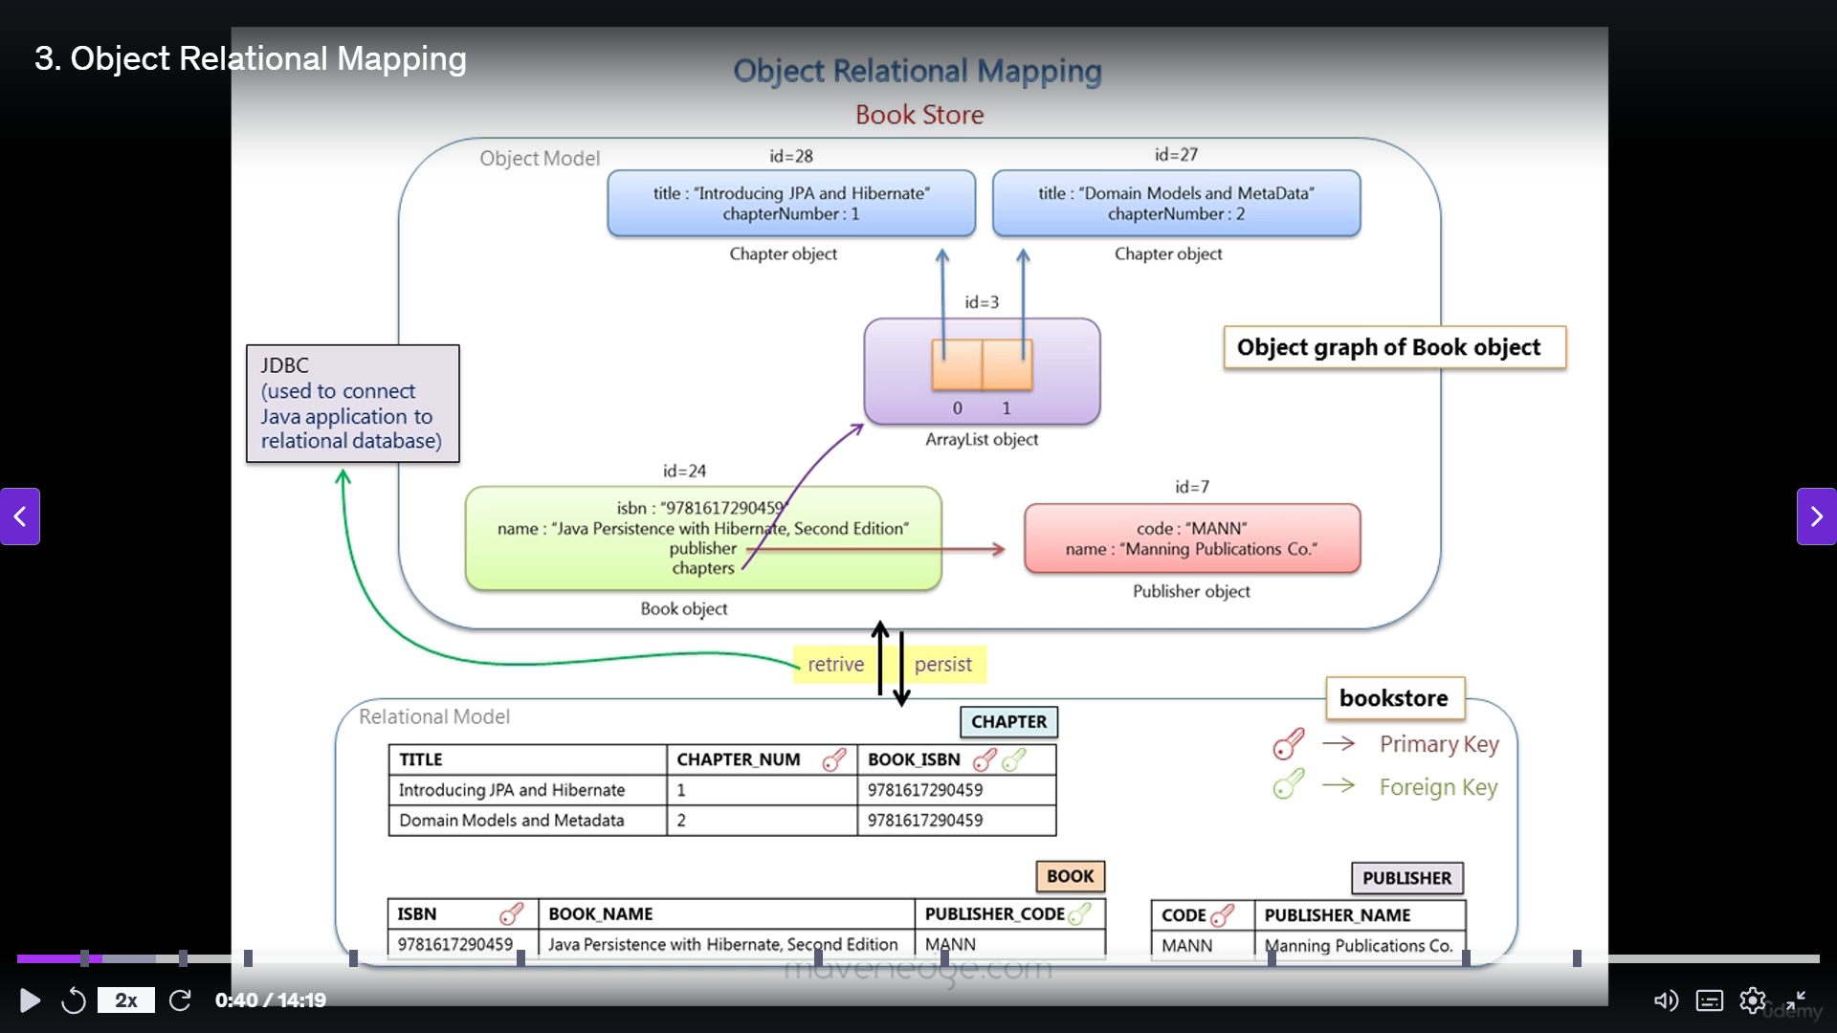  
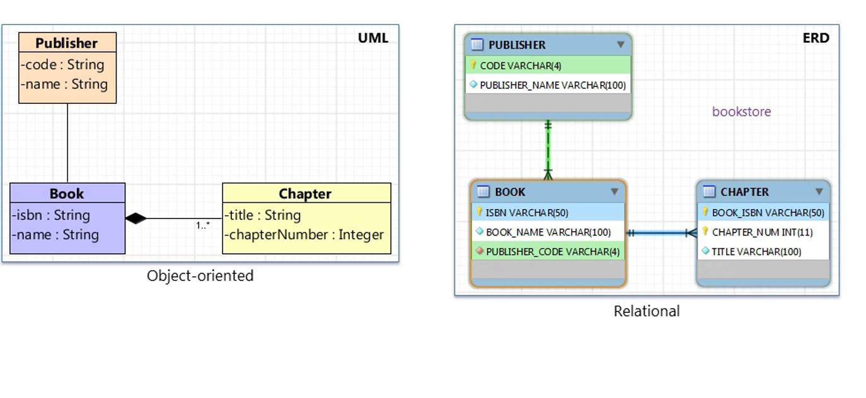  
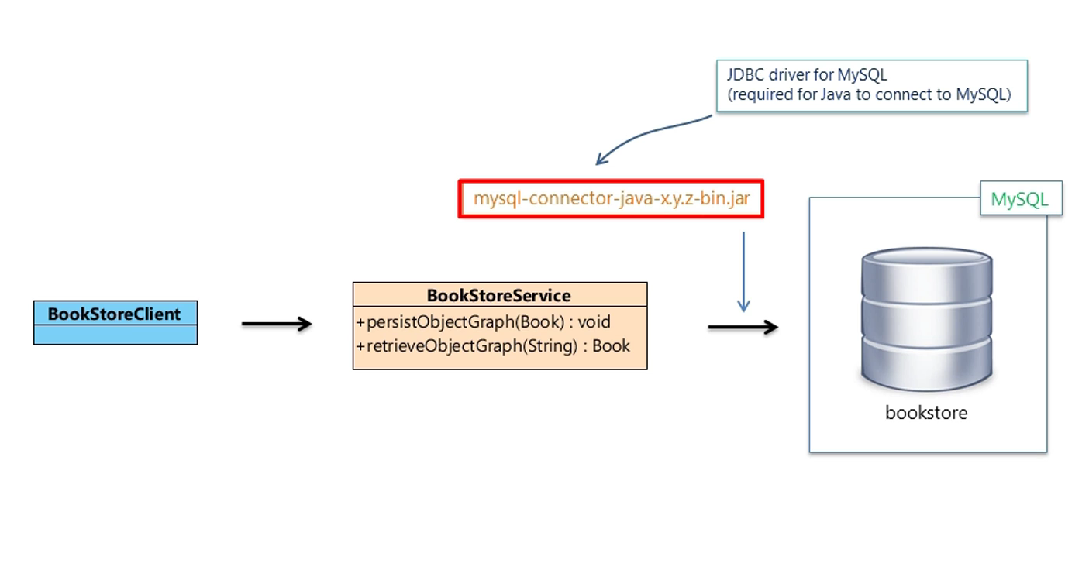  
**Steps using JDBc**  
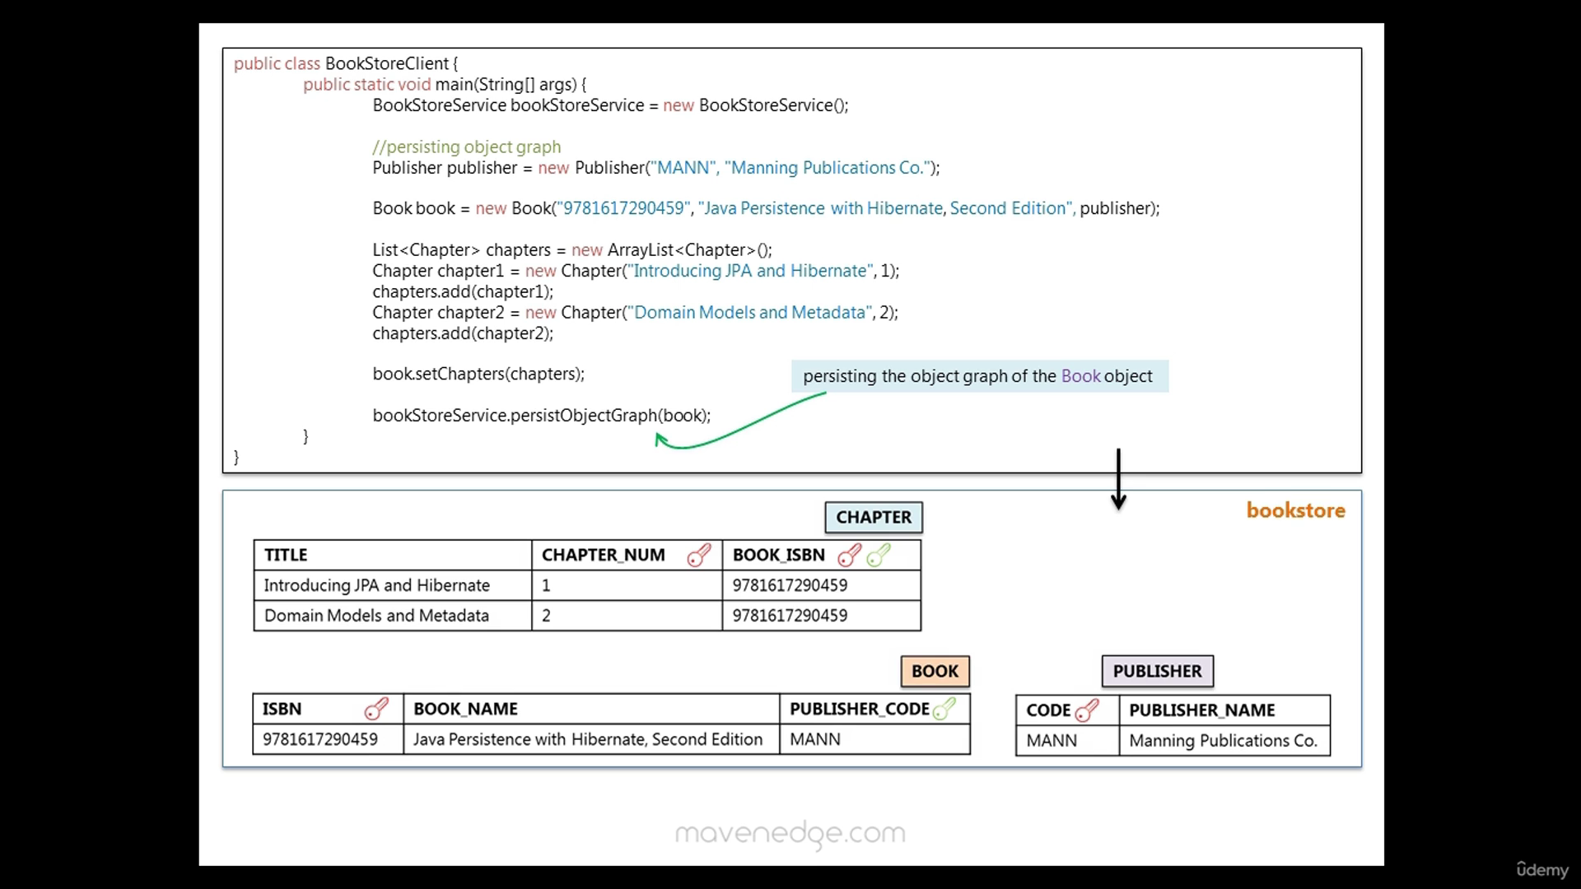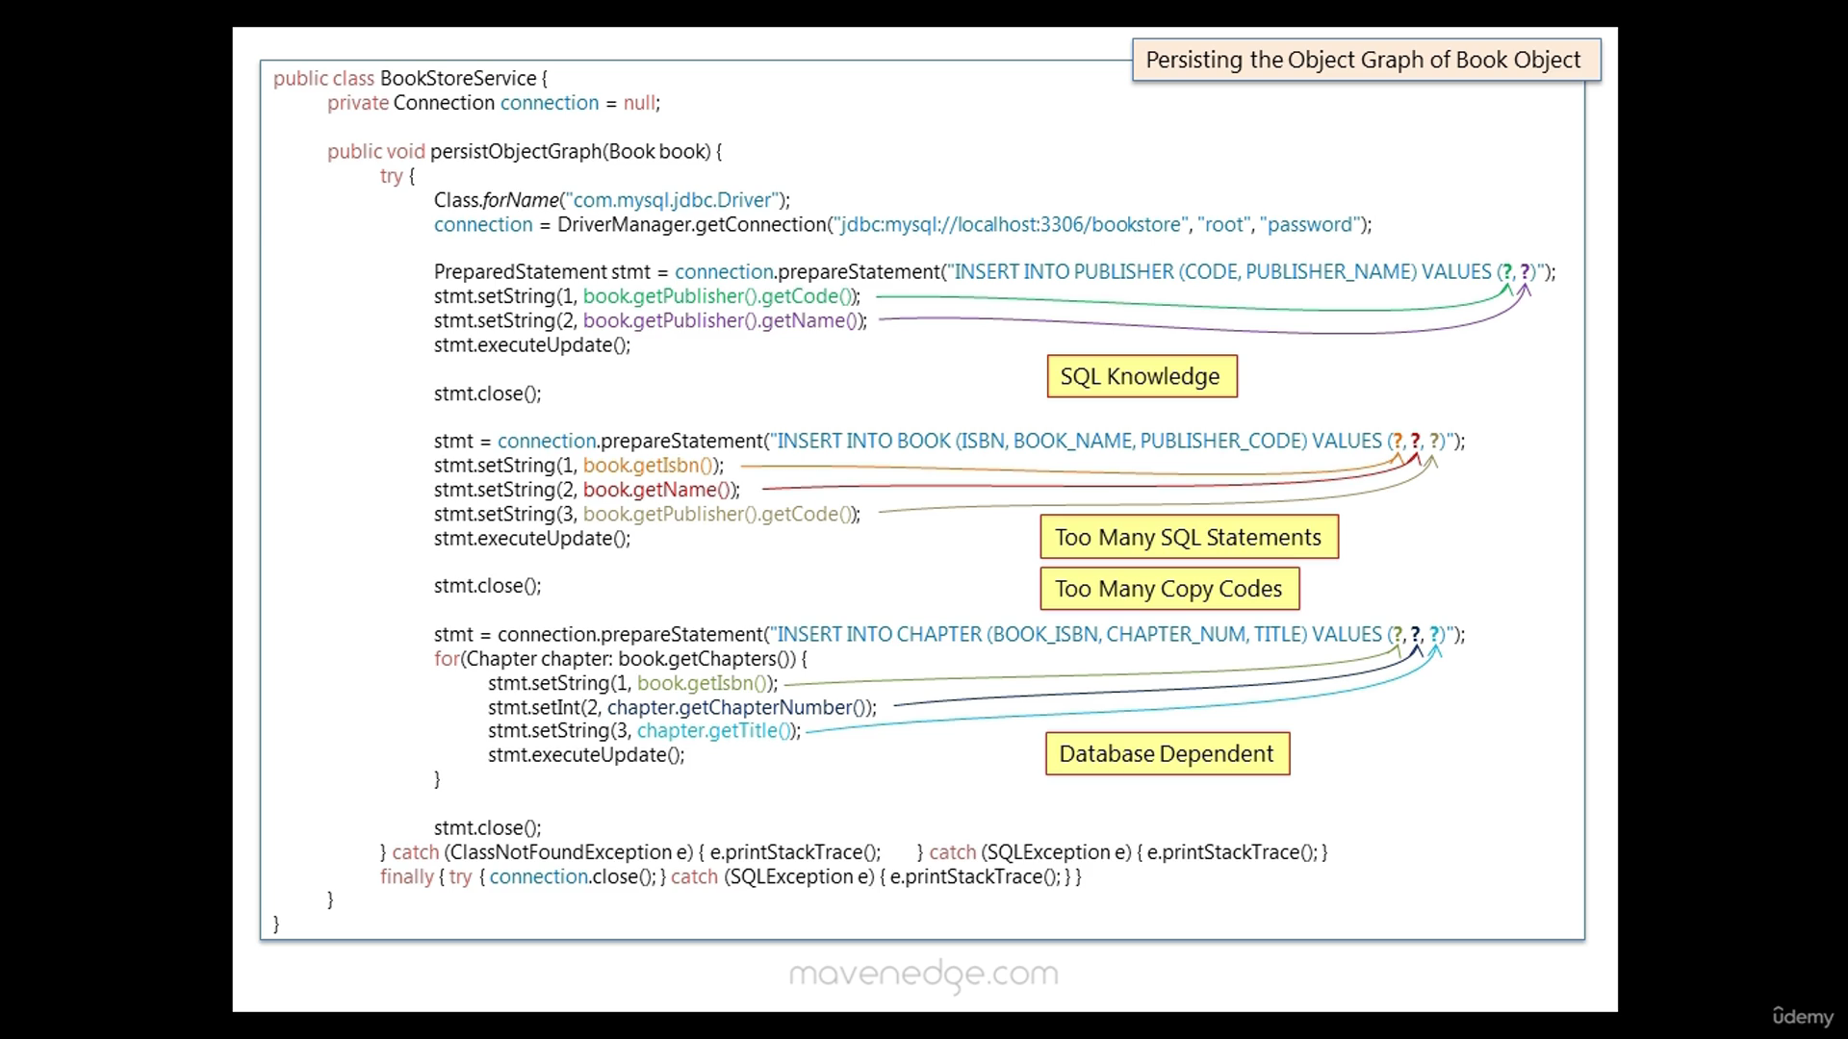 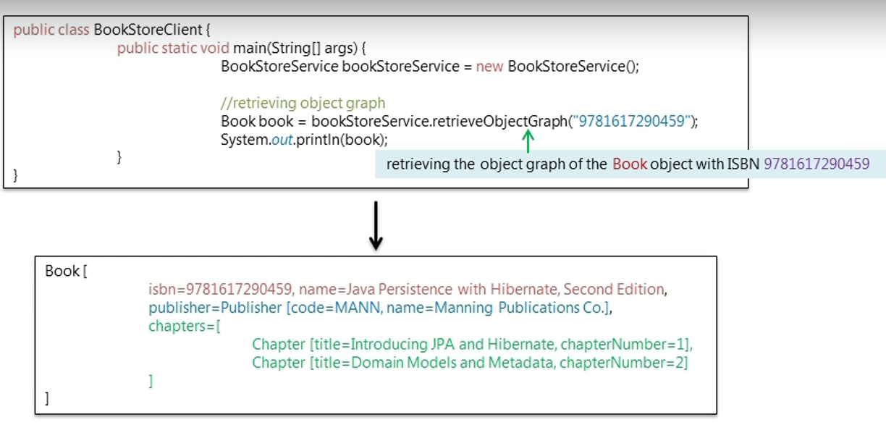

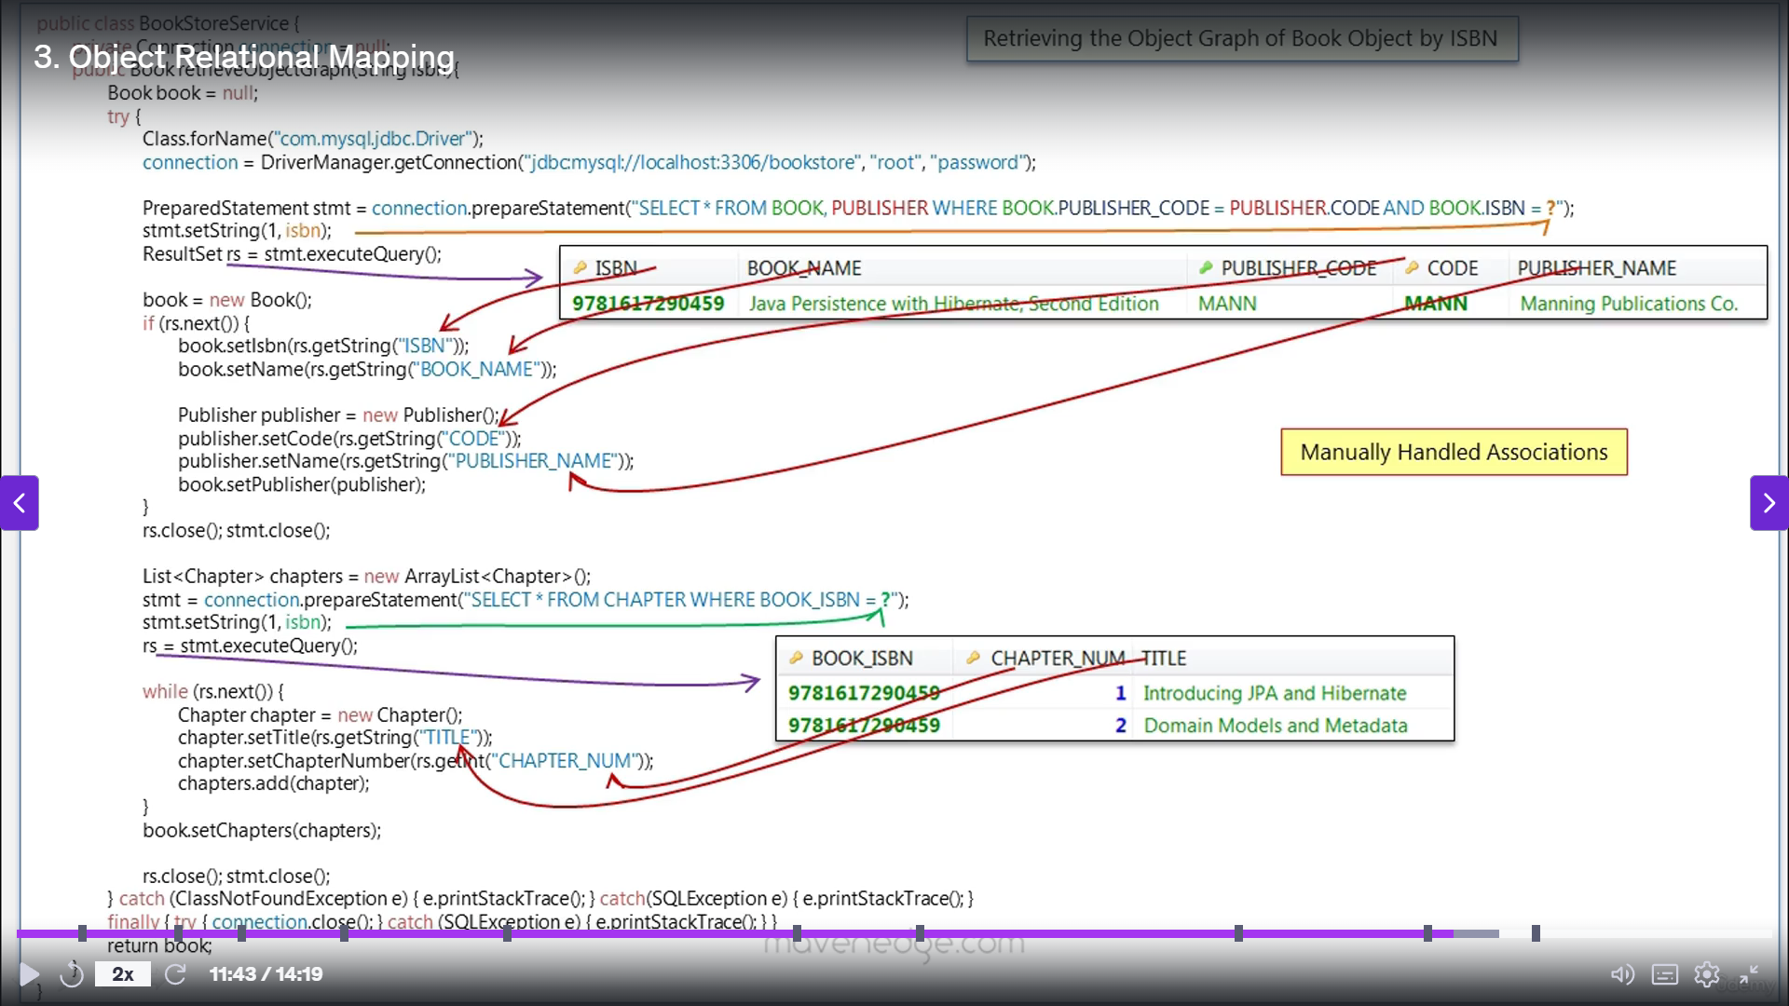  
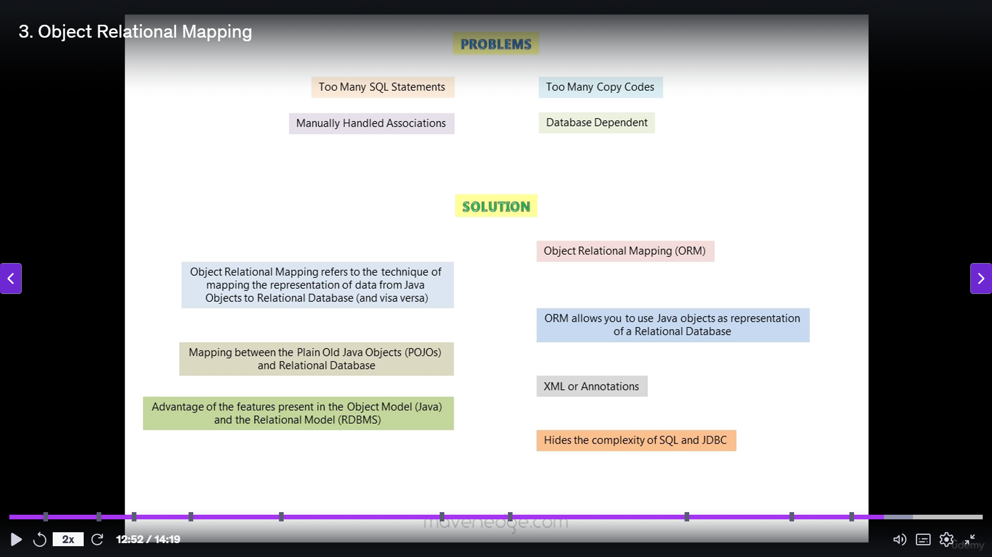  
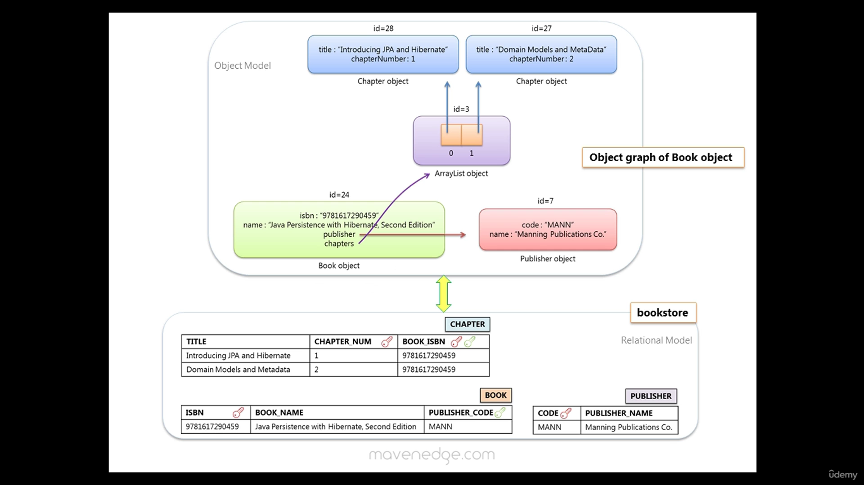  
  
  
  
  
  
**ORM**

it is a programming technique for converting data between incompatible type systems using object-oriented programming languages.  
It means you can write database queries using the object oriented paradigm of your preferred language and there are many free and commercial packages available that perform object relational mapping

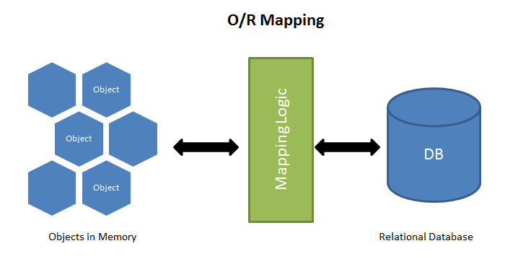

ORM sets the mapping between the set of objects which are written in the preferred programming language like *JavaScript* and relational database like SQL. It hides and encapsulates the SQL queries into objects and instead of SQL queries we can use directly the objects to implement the SQL query.

**Why to use ORM and What are the benefits of ORM?**

Now the question arises that if we can use directly the queries then why to include the ORM frameworks in between.

So, first of all you get to write in the language you are already using. It is sometime tough to write SQL queries directly as they are complicated in some cases. So, to maintain the fluency we use ORM, so that we can write in the language we know.

Second, it hides the SQL or any other database query away from your application logic.

Third, for heavy database usage like creating 10+ tables and using many queries in them, then it is good to use ORM as it reduce the code and give better understanding of the code to you and as well as to your team mates and it makes your application faster and easier to maintain.

*So, lets conclude the article in a very simple line that, ORM is used to write Database queries in the preferred languages instead of writing the Raw Database queries.*

JPA (Java Persistence API) is a Java specification for managing relational databases, while Hibernate is a popular and widely used implementation of JPA that provides object-relational mapping (ORM) capabilities.

Here's a more detailed breakdown:

* **JPA:**
  + Is a Java specification that defines how to persist data in Java applications.
  + Provides a standard API for interacting with relational databases, allowing developers to map Java objects to database tables.
  + Is not an implementation itself, but rather a set of interfaces and annotations that ORM frameworks like Hibernate can implement.
  + Uses Java Persistence Query Language (JPQL) for database operations.
* **Hibernate:**
  + Is a full-fledged implementation of the JPA specification.
  + Provides ORM capabilities, allowing developers to work with objects in their code, abstracting the complexities of database operations.
  + Uses Hibernate Query Language (HQL) for database operations.
  + Can be used in any environment supporting JPA, including Java SE applications, Java EE application servers, and Enterprise OSGi containers.
  + Hibernate also provides features beyond the JPA specification, such as advanced caching and query optimization.

Key Differences:

|  |  |  |
| --- | --- | --- |
| **Feature** | **JPA** | **Hibernate** |
| Nature | Specification/Standard | Implementation |
| Query Language | JPQL | HQL |
| Focus | Interfacing with databases | Providing ORM capabilities |
| Portability | Designed for portability across different ORM frameworks | Provides specific features and extensions beyond JPA |
| Implementation | Not a concrete implementation | A concrete implementation of JPA |

In Summary:

Think of JPA as the blueprint for how to interact with databases in Java, while Hibernate is a specific tool that follows that blueprint to build and manage database interactions.

**Hibernate**Hibernate is a ORM tool used for mapping Java Objects to a Relational Database  
it allows us how to connect to database and also the way the java objects are mapped to database Hibernate allows us to use java Objects in our application as we are representing Relational Data in a Database

**Transaction**A transaction is a group of operations that are run as a single unit of work  
**Commit**tells the database to commit any changes mad in this transaction  
**Rollback**tells the database to rollback any changes mad in this transaction  
  
**Aggregation**   
Indicates a relation between whole and its parts

In aggregation when the whole is destroyed its parts are not destroyed with it  
**Composition**

Indicates a relation between whole and its parts

In aggregation when the whole is destroyed its parts are destroyed with it

**Entities and Value Types**

* An Object of entity type has its own database identity(Primary key value)
* An Object of value type has no database identity(Primary key value) it belongs to an entity
* The lifecycle of value type object is bound to that of its own entity object

value type objects are identified through the owning entity

* Classes like String and integer are most simple **value type** classes
* Dos the database identity of an object mtters  
  if yes🡪Entity No🡪Value type  
  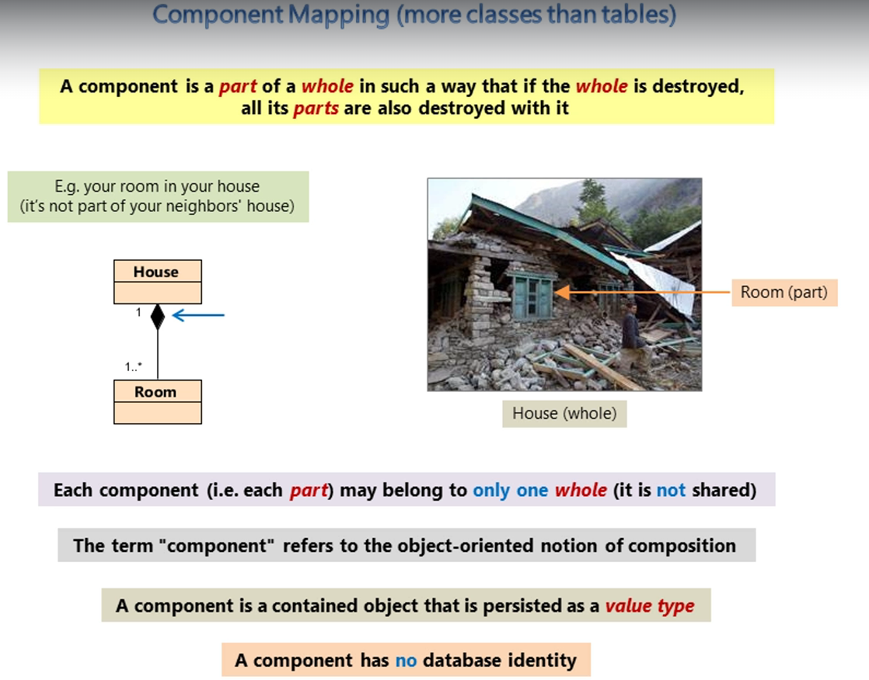

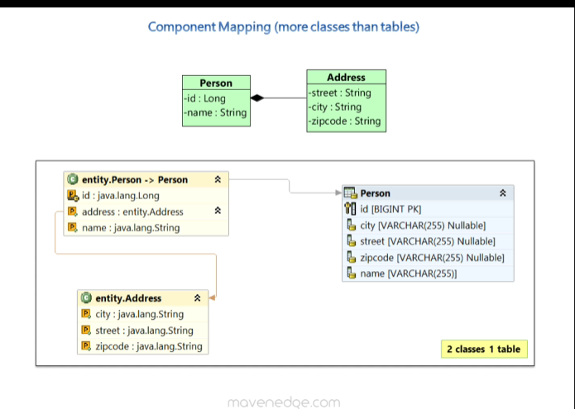

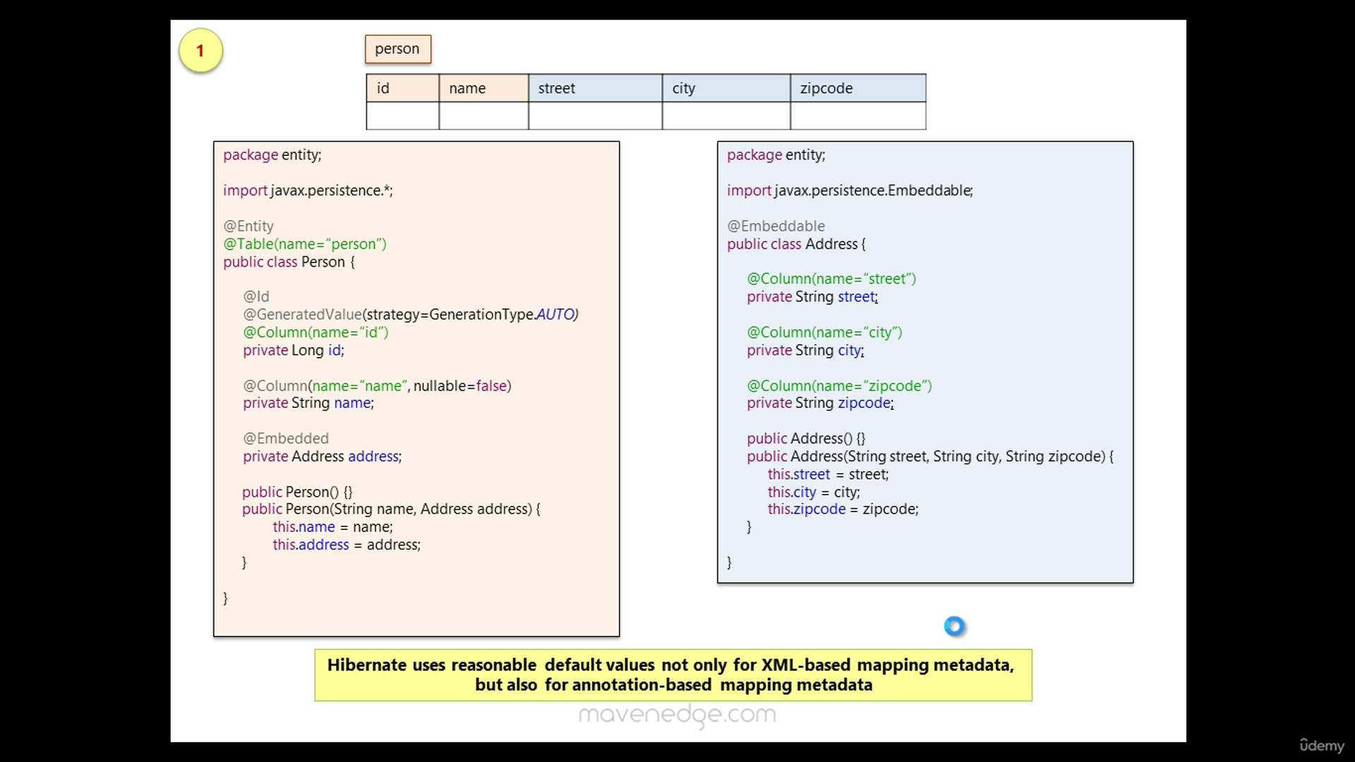  
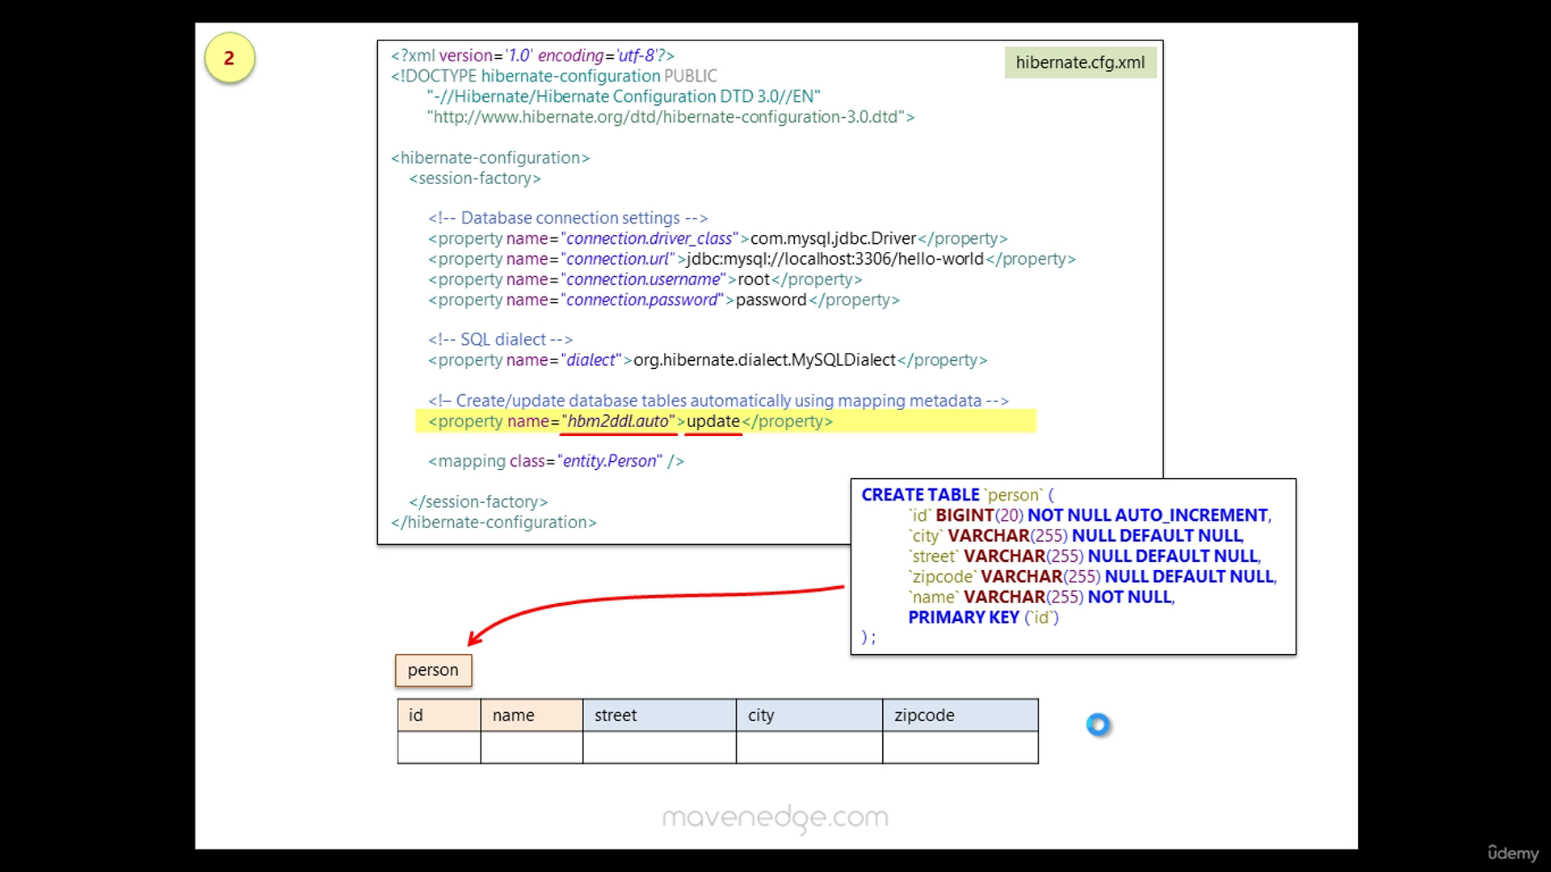  
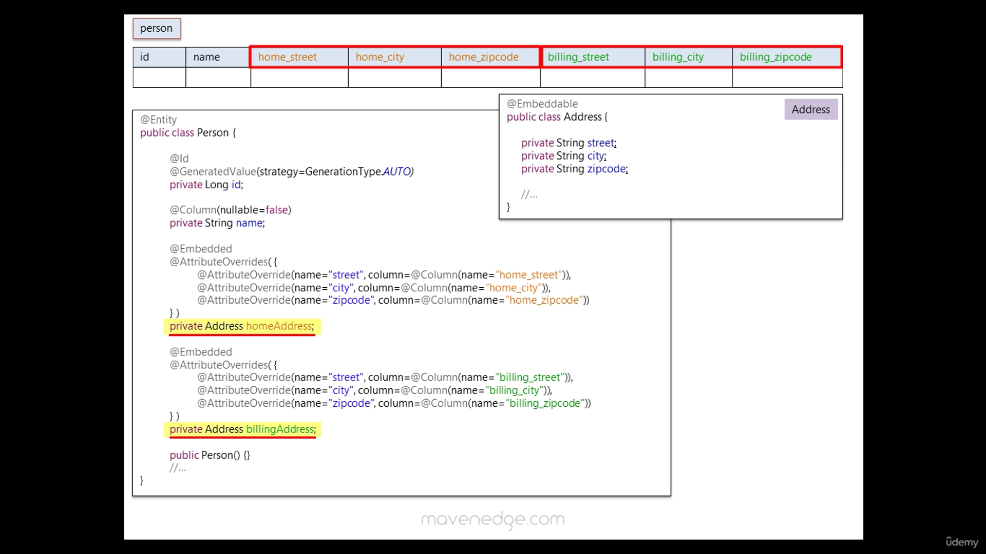

**Mapping Associations-Many to One**

**Many-to-One Relationship**

A many-to-one relationship is the inverse of a one-to-many relationship. It means that many instances of one entity are related to a single instance of another entity. For example, many Employees can belong to one Department.

**Cascades in JPA/Hibernate**

Cascading is a feature in JPA/Hibernate that allows operations to be propagated from a parent entity to its related child entities. Common cascade types include:

* **CascadeType.PERSIST**: When the parent entity is persisted, the child entities are also persisted.
* **CascadeType.REMOVE**: When the parent entity is removed, the child entities are also removed.
* **CascadeType.MERGE**: When the parent entity is merged, the child entities are also merged.
* **CascadeType.REFRESH**: When the parent entity is refreshed, the child entities are also refreshed.
* **CascadeType.ALL**: Applies all the above cascade types.  
    
  **One-to-Many Relationship**
* A one-to-many relationship means that one entity is related to multiple instances of another entity. For example, a Department can have many Employees. In JPA/Hibernate, this is typically represented using the @OneToMany annotation on the parent entity and @ManyToOne on the child entity.  
    
  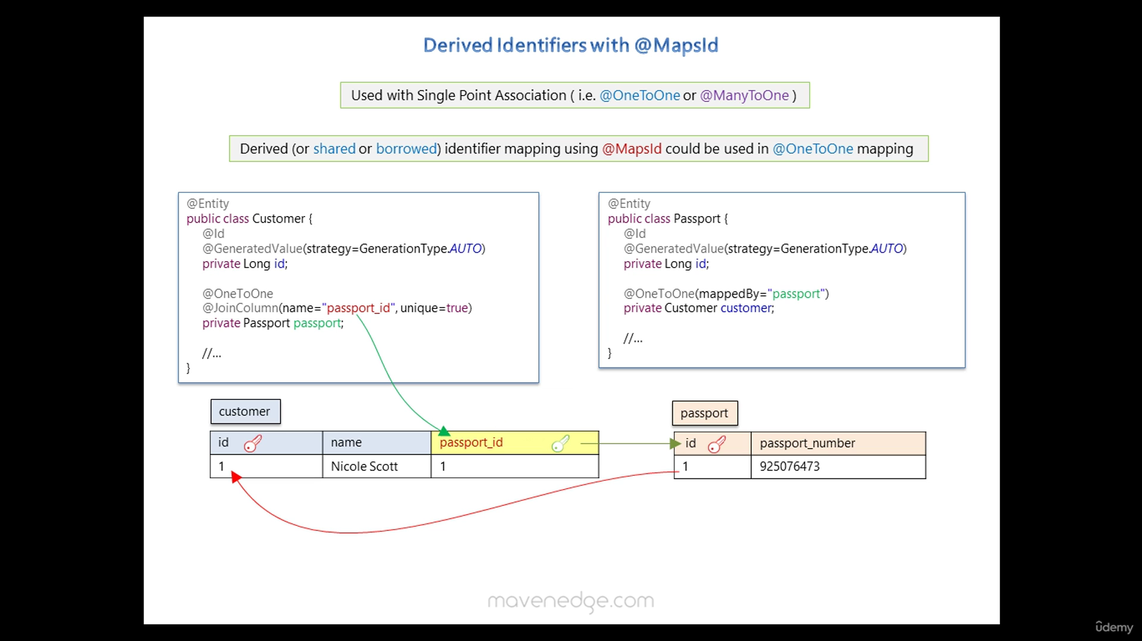

**Choosing Cascade Types**

* **PERSIST**: Useful when you want to save child entities automatically when saving the parent.
* **MERGE**: Useful for updating child entities when updating the parent.
* **REMOVE**: Useful for deleting child entities when deleting the parent.
* **REFRESH**: Useful for reloading child entities when reloading the parent.
* **DETACH**: Useful for detaching child entities when detaching the parent.
* **ALL**: Useful when you want to apply all cascade operations.

**8. What are the wait() and sleep() methods?**

**wait()**: As the name suggests, it is a non-static method belongs to Object class that causes the current thread to wait and go to sleep until some other threads call the notify () or notifyAll() method for the object’s monitor (lock). It simply releases the lock and is mostly used for inter-thread communication. It is defined in the object class and should only be called from a synchronized context.

Example:

**synchronized**(monitor)

{

monitor.wait(); Here Lock Is Released by Current Thread

}

**sleep()**: As the name suggests, it is a static method that pauses or stops the execution of the current thread for some specified period. It doesn’t release the lock while waiting and is mostly used to introduce pause on execution. It is defined in thread class, and no need to call from a synchronized context.

Example:

**synchronized**(monitor)

{

Thread.sleep(1000); Here Lock Is Held by The Current Thread

//after 1000 milliseconds, the current thread will wake up, or after we call that is interrupt() method

}

**wait() and sleep() are both used to pause thread execution in Java, but they function differently:**

* **sleep():**
  + It is a static method of the Thread class.
  + It pauses the execution of the current thread for a specified duration.
  + It does not release any locks held by the thread.
  + It can be called from any context.
  + If interrupted, it throws an InterruptedException.
  + It is typically used for simple pauses or delays, and not for inter-thread communication.
  + Example:

Java

Thread.sleep(1000); // Pauses the current thread for 1 second

* **wait():**
  + It is an instance method of the Object class.
  + It pauses the execution of the current thread and releases the lock on the object.
  + It must be called within a synchronized block or method that holds the lock on the object.
  + The thread enters the waiting state until another thread calls notify() or notifyAll() on the same object.
  + If interrupted, it throws an InterruptedException.
  + It is used for inter-thread communication and synchronization, where one thread needs to wait for a specific condition before proceeding.
  + Example:

synchronized (lock) {

lock.wait(); // Releases the lock and waits for notification

}

**Difference between wait and sleep** :

| **Wait()** | **Sleep()** |
| --- | --- |
| Wait() method belongs to Object class. | Sleep() method belongs to Thread class. |
| Wait() method releases lock during Synchronization. | Sleep() method does not release the lock on object during Synchronization. |
| Wait() should be called only from Synchronized context. | There is no need to call sleep() from Synchronized context. |
| Wait() is not a static method. | Sleep() is a static method. |
| Wait() Has Three Overloaded Methods:   * wait() * wait(long timeout) * wait(long timeout, int nanos) | Sleep() Has Two Overloaded Methods:   * sleep(long millis)millis: milliseconds * sleep(long millis,int nanos) nanos: Nanoseconds |
| public final void wait(long timeout) | public static void sleep(long millis) throws Interrupted_Execption |

**9. What’s the difference between notify() and notifyAll()?**

**notify()**: It sends a notification and wakes up only a single thread instead of multiple threads that are waiting on the object’s monitor.

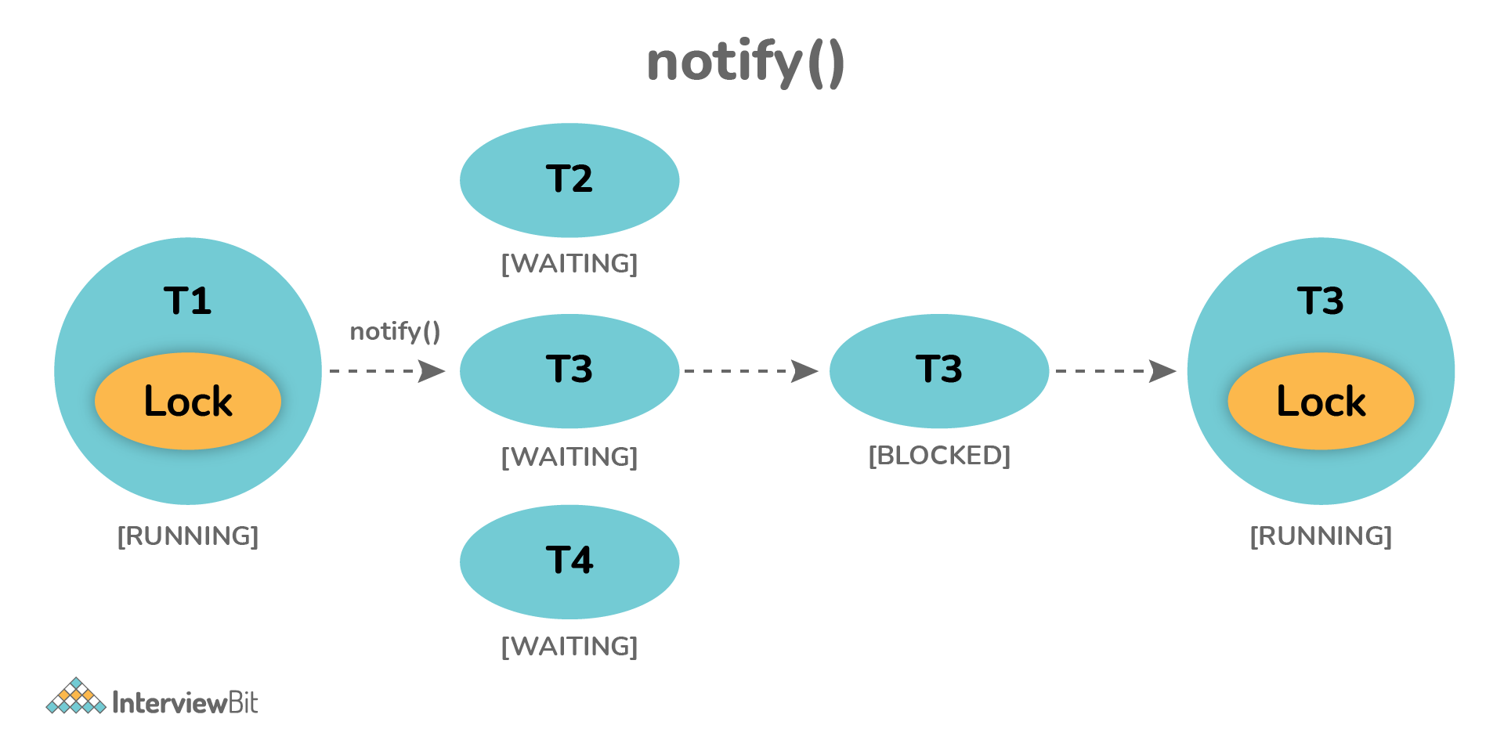

**notifyAll()**: It sends notifications and wakes up all threads and allows them to compete for the object's monitor instead of a single thread.

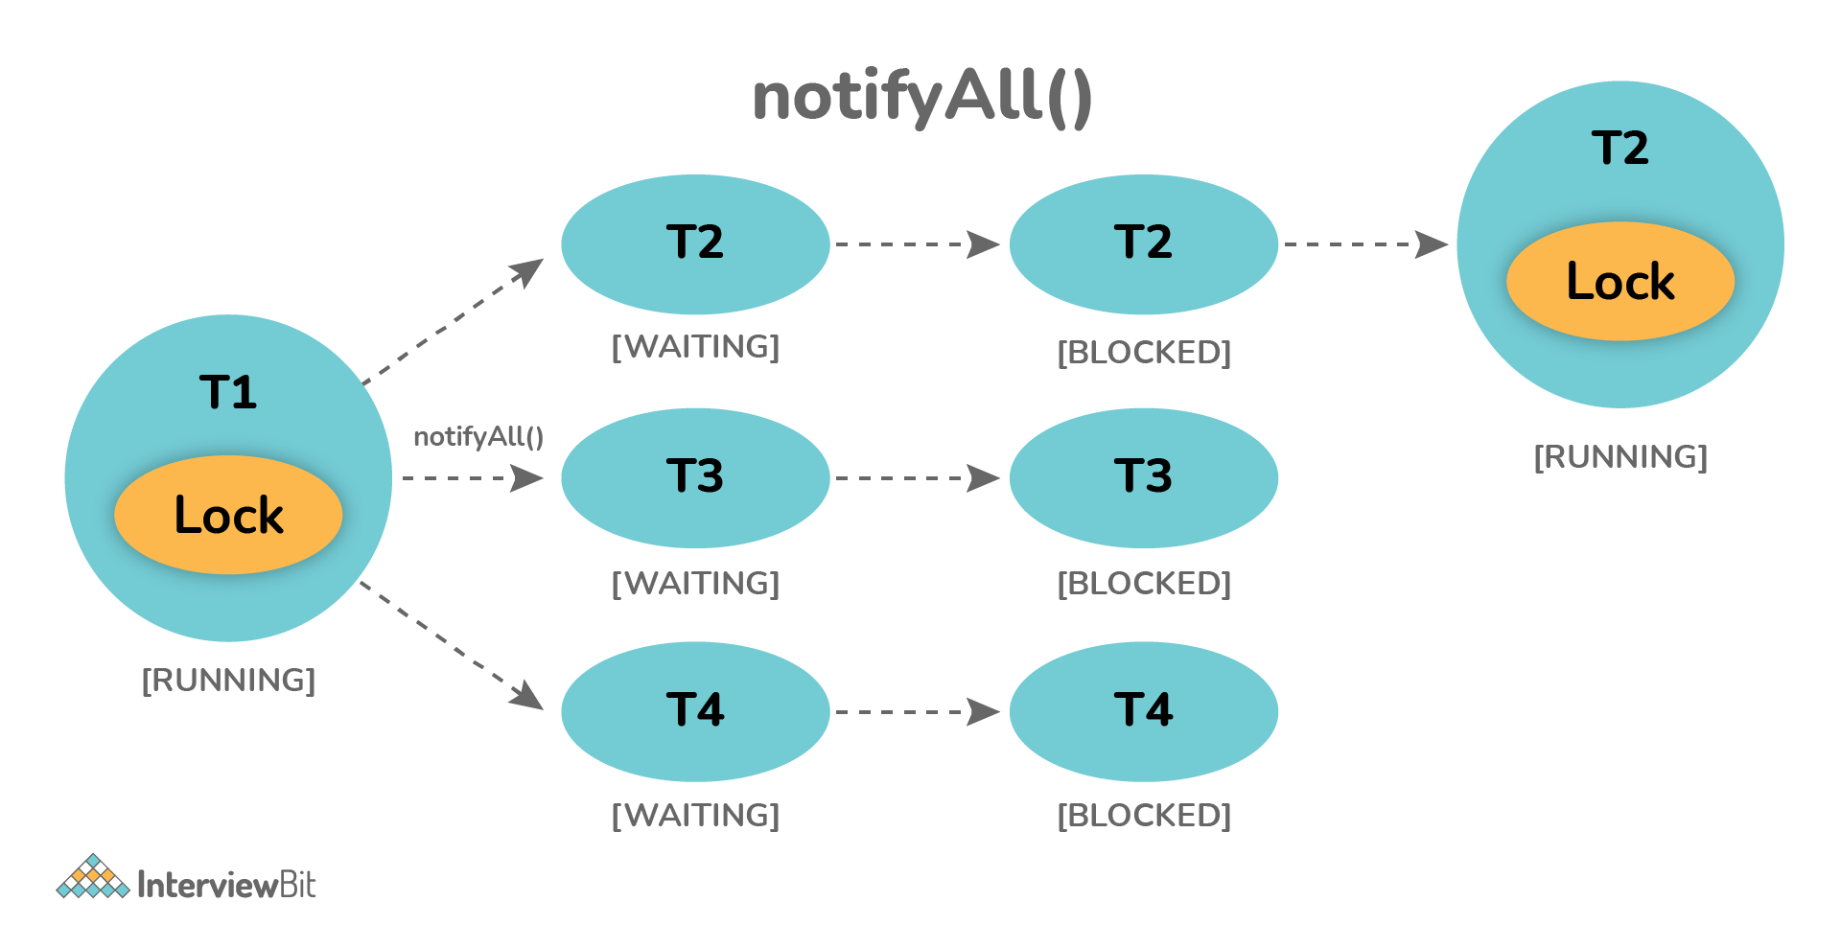

**10. Why wait(), notify(), and notifyAll() methods are present in Object class?**

We know that every object has a monitor that allows the thread to hold a lock on the object. But the thread class doesn't contain any monitors. Thread usually waits for the object’s monitor (lock) by calling the wait() method on an object, and notify other threads that are waiting for the same lock using notify() or notifyAll() method.  Therefore, these three methods are called on objects only and allow all threads to communicate with each that are created on that object.

**11. What is Runnable and Callable Interface? Write the difference between them.**

Both the interfaces are generally used to encapsulate tasks that are needed to be executed by another thread. But there are some differences between them as given below:   
  
**Running Interface**: This interface is basically available in Java right from the beginning. It is simply used to execute code on a concurrent thread.    
**Callable Interface**: This interface is basically a new one that was introduced as a part of the concurrency package. It addresses the limitation of runnable interfaces along with some major changes like generics, enum, static imports, variable argument method, etc. It uses generics to define the return type of object.

**public** **interface** **Runnable**

{

**public** **abstract** **void** **run**();

}

**public** **interface** **Callable**<**V**>

{

V **call**() **throws** Exception;

}

**Runnable Interface vs Callable Interface**

| **Runnable Interface** | **Callable Interface** |
| --- | --- |
| It does not return any result and therefore, cannot throw a checked exception. | It returns a result and therefore, can throw an exception. |
| It cannot be passed to invokeAll method. | It can be passed to invokeAll method. |
| It was introduced in JDK 1.0. | It was introduced in JDK 5.0, so one cannot use it before Java 5. |
| It simply belongs to Java.lang. | It simply belongs to java.util.concurrent. |
| It uses the run() method to define a task. | It uses the call() method to define a task. |
| To use this interface, one needs to override the run() method. | To use this interface, one needs to override the call() method |

departments Table:

DepIDNum Depname

101 HR

102 Engineering

103 Marketing

employees Table:

EmpId EMPName DepIDNum 104 Sales

1 Alice 101

2 Bob 102

3 Charlie 101

4 David 103

5 Eve NULL

1. 🔗 INNER JOIN

Returns only the rows with matching DepIDNum in both tables.

EmpId EMPName DepIDNum Depname

1 Alice 101 HR

2 Bob 102 Engineering

3 Charlie 101 HR

4 David 103 Marketing

======================

2. 🔙 LEFT JOIN

Returns all rows from employees, and matched rows from departments. Unmatched departments show NULL.

EmpId EMPName DepIDNum Depname

1 Alice 101 HR

2 Bob 102 Engineering

3 Charlie 101 HR

4 David 103 Marketing

5 Eve NULL NULL

========================================

3. 🔜 RIGHT JOIN

Returns all rows from departments, and matched rows from employees. Unmatched employees show NULL.

EmpId EMPName DepIDNum Depname

1 Alice 101 HR

3 Charlie 101 HR

2 Bob 102 Engineering

4 David 103 Marketing

NULL NULL 104 Sales

======================

4. 🔄 FULL OUTER JOIN

Returns all rows from both tables. Unmatched rows show NULL in missing columns.

EmpId EMPName DepIDNum Depname

1 Alice 101 HR

3 Charlie 101 HR

2 Bob 102 Engineering

4 David 103 Marketing

NULL NULL 104 Sales

5 Eve NULL NULL

====================

5. 🔁 CROSS JOIN

Returns the Cartesian product — every combination of rows from both tables.

EmpId EMPName DepIDNum (Emp) DepIDNum (Dept) Depname

1 Alice 101 101 HR

1 Alice 101 102 Engineering

... ... ... ... ...

5 Eve NULL 104 Sales

(20 total rows: 5 employees × 4 departments)